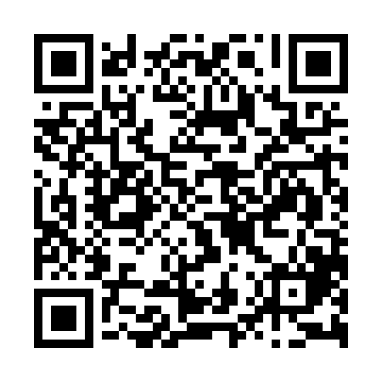

**Prayer times for Palmerston, New Zealand**

**Fri 1 Nov 2024 - Sat 30 Nov 2024**

**High Latitude Method: None**

**Prayer Calculation Method: Muslim World League**

**Asar Calculation Method: Shafi**

|  |  |  |  |  |  |  |  |
| --- | --- | --- | --- | --- | --- | --- | --- |
| **Date** | **Day** | **Fajr** | **Sunrise** | **Dhuhr** | **Asr** | **Maghrib** | **Isha** |
| 1 | Fri | 4:18 | 6:15 | 1:21 | 5:16 | 8:27 | 10:17 |
| 2 | Sat | 4:15 | 6:13 | 1:21 | 5:17 | 8:29 | 10:19 |
| 3 | Sun | 4:13 | 6:12 | 1:21 | 5:17 | 8:30 | 10:21 |
| 4 | Mon | 4:11 | 6:11 | 1:21 | 5:18 | 8:32 | 10:24 |
| 5 | Tue | 4:09 | 6:09 | 1:21 | 5:18 | 8:33 | 10:26 |
| 6 | Wed | 4:07 | 6:08 | 1:21 | 5:19 | 8:34 | 10:28 |
| 7 | Thu | 4:04 | 6:07 | 1:21 | 5:20 | 8:36 | 10:30 |
| 8 | Fri | 4:02 | 6:05 | 1:21 | 5:20 | 8:37 | 10:32 |
| 9 | Sat | 4:00 | 6:04 | 1:21 | 5:21 | 8:39 | 10:34 |
| 10 | Sun | 3:58 | 6:03 | 1:21 | 5:21 | 8:40 | 10:37 |
| 11 | Mon | 3:56 | 6:01 | 1:21 | 5:22 | 8:42 | 10:39 |
| 12 | Tue | 3:54 | 6:00 | 1:21 | 5:23 | 8:43 | 10:41 |
| 13 | Wed | 3:52 | 5:59 | 1:21 | 5:23 | 8:45 | 10:43 |
| 14 | Thu | 3:49 | 5:58 | 1:22 | 5:24 | 8:46 | 10:46 |
| 15 | Fri | 3:47 | 5:57 | 1:22 | 5:24 | 8:47 | 10:48 |
| 16 | Sat | 3:45 | 5:56 | 1:22 | 5:25 | 8:49 | 10:50 |
| 17 | Sun | 3:43 | 5:55 | 1:22 | 5:26 | 8:50 | 10:52 |
| 18 | Mon | 3:41 | 5:54 | 1:22 | 5:26 | 8:52 | 10:55 |
| 19 | Tue | 3:39 | 5:53 | 1:23 | 5:27 | 8:53 | 10:57 |
| 20 | Wed | 3:38 | 5:52 | 1:23 | 5:27 | 8:54 | 10:59 |
| 21 | Thu | 3:36 | 5:51 | 1:23 | 5:28 | 8:56 | 11:01 |
| 22 | Fri | 3:34 | 5:50 | 1:23 | 5:29 | 8:57 | 11:04 |
| 23 | Sat | 3:32 | 5:49 | 1:24 | 5:29 | 8:58 | 11:06 |
| 24 | Sun | 3:30 | 5:49 | 1:24 | 5:30 | 9:00 | 11:08 |
| 25 | Mon | 3:28 | 5:48 | 1:24 | 5:31 | 9:01 | 11:10 |
| 26 | Tue | 3:27 | 5:47 | 1:24 | 5:31 | 9:02 | 11:12 |
| 27 | Wed | 3:25 | 5:47 | 1:25 | 5:32 | 9:04 | 11:14 |
| 28 | Thu | 3:23 | 5:46 | 1:25 | 5:32 | 9:05 | 11:16 |
| 29 | Fri | 3:22 | 5:45 | 1:25 | 5:33 | 9:06 | 11:19 |
| 30 | Sat | 3:20 | 5:45 | 1:26 | 5:34 | 9:07 | 11:21 |

**Prayer times provided by https://www.salahtimes.com**