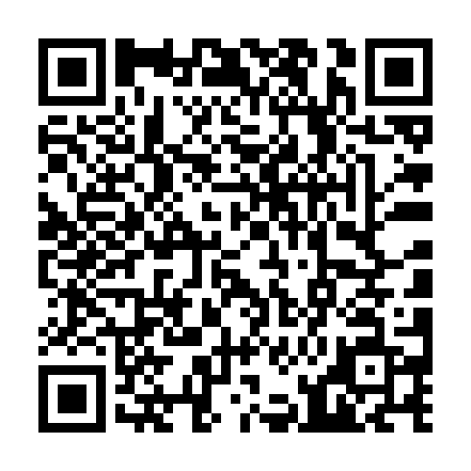
Prayer times for Utshimauat Katipaitsheht Kauitshiht, Quebec, Canada
Wed 1 May 2024 - Fri 31 May 2024
High Latitude Method: Angle Based Rule
Prayer Calculation Method: Islamic Society of North America
Asar Calculation Method: Hanafi

Date | Day | Fajr | Sunrise | Dhuhr | Asr | Maghrib | Isha
1 | Wed | 2:28 | 4:27 | 11:55 | 5:03 | 7:23 | 9:23
2 | Thu | 2:25 | 4:25 | 11:54 | 5:04 | 7:25 | 9:26
3 | Fri | 2:22 | 4:23 | 11:54 | 5:05 | 7:27 | 9:29
4 | Sat | 2:19 | 4:21 | 11:54 | 5:06 | 7:28 | 9:31
5 | Sun | 2:16 | 4:19 | 11:54 | 5:07 | 7:30 | 9:34
6 | Mon | 2:13 | 4:18 | 11:54 | 5:08 | 7:32 | 9:37
7 | Tue | 2:10 | 4:16 | 11:54 | 5:09 | 7:33 | 9:40
8 | Wed | 2:06 | 4:14 | 11:54 | 5:09 | 7:35 | 9:43
9 | Thu | 2:03 | 4:12 | 11:54 | 5:10 | 7:36 | 9:45
10 | Fri | 2:02 | 4:11 | 11:54 | 5:11 | 7:38 | 9:46
11 | Sat | 2:02 | 4:09 | 11:54 | 5:12 | 7:40 | 9:47
12 | Sun | 2:01 | 4:07 | 11:54 | 5:13 | 7:41 | 9:48
13 | Mon | 2:00 | 4:06 | 11:54 | 5:14 | 7:43 | 9:48
14 | Tue | 1:59 | 4:04 | 11:54 | 5:15 | 7:44 | 9:49
15 | Wed | 1:59 | 4:03 | 11:54 | 5:16 | 7:46 | 9:50
16 | Thu | 1:58 | 4:01 | 11:54 | 5:17 | 7:47 | 9:51
17 | Fri | 1:57 | 4:00 | 11:54 | 5:18 | 7:49 | 9:52
18 | Sat | 1:56 | 3:58 | 11:54 | 5:19 | 7:50 | 9:52
19 | Sun | 1:56 | 3:57 | 11:54 | 5:20 | 7:52 | 9:53
20 | Mon | 1:55 | 3:56 | 11:54 | 5:20 | 7:53 | 9:54
21 | Tue | 1:54 | 3:54 | 11:54 | 5:21 | 7:55 | 9:55
22 | Wed | 1:54 | 3:53 | 11:54 | 5:22 | 7:56 | 9:55
23 | Thu | 1:53 | 3:52 | 11:54 | 5:23 | 7:57 | 9:56
24 | Fri | 1:53 | 3:51 | 11:54 | 5:24 | 7:59 | 9:57
25 | Sat | 1:52 | 3:50 | 11:55 | 5:24 | 8:00 | 9:57
26 | Sun | 1:52 | 3:49 | 11:55 | 5:25 | 8:01 | 9:58
27 | Mon | 1:51 | 3:48 | 11:55 | 5:26 | 8:03 | 9:59
28 | Tue | 1:51 | 3:47 | 11:55 | 5:27 | 8:04 | 9:59
29 | Wed | 1:50 | 3:46 | 11:55 | 5:27 | 8:05 | 10:00
30 | Thu | 1:50 | 3:45 | 11:55 | 5:28 | 8:06 | 10:01
31 | Fri | 1:50 | 3:44 | 11:55 | 5:29 | 8:07 | 10:01
Prayer times provided by https://www.salahtimes.com

