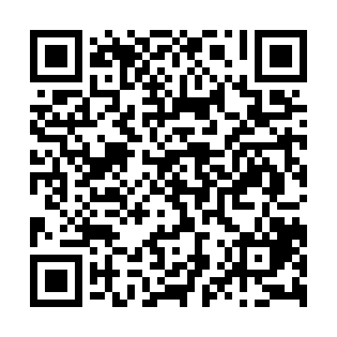

**Prayer times for Wellington, New Zealand**

**Fri 1 Nov 2024 - Sat 30 Nov 2024**

**High Latitude Method: None**

**Prayer Calculation Method: Muslim World League**

**Asar Calculation Method: Shafi**

|  |  |  |  |  |  |  |  |
| --- | --- | --- | --- | --- | --- | --- | --- |
| **Date** | **Day** | **Fajr** | **Sunrise** | **Dhuhr** | **Asr** | **Maghrib** | **Isha** |
| 1 | Fri | 4:22 | 6:08 | 1:05 | 4:56 | 8:02 | 9:41 |
| 2 | Sat | 4:20 | 6:06 | 1:04 | 4:56 | 8:03 | 9:43 |
| 3 | Sun | 4:19 | 6:05 | 1:04 | 4:56 | 8:05 | 9:44 |
| 4 | Mon | 4:17 | 6:04 | 1:04 | 4:57 | 8:06 | 9:46 |
| 5 | Tue | 4:15 | 6:03 | 1:05 | 4:57 | 8:07 | 9:48 |
| 6 | Wed | 4:13 | 6:01 | 1:05 | 4:58 | 8:08 | 9:49 |
| 7 | Thu | 4:12 | 6:00 | 1:05 | 4:58 | 8:09 | 9:51 |
| 8 | Fri | 4:10 | 5:59 | 1:05 | 4:59 | 8:11 | 9:53 |
| 9 | Sat | 4:08 | 5:58 | 1:05 | 4:59 | 8:12 | 9:55 |
| 10 | Sun | 4:07 | 5:57 | 1:05 | 4:59 | 8:13 | 9:56 |
| 11 | Mon | 4:05 | 5:56 | 1:05 | 5:00 | 8:14 | 9:58 |
| 12 | Tue | 4:04 | 5:55 | 1:05 | 5:00 | 8:16 | 10:00 |
| 13 | Wed | 4:02 | 5:54 | 1:05 | 5:01 | 8:17 | 10:02 |
| 14 | Thu | 4:00 | 5:53 | 1:05 | 5:01 | 8:18 | 10:04 |
| 15 | Fri | 3:59 | 5:52 | 1:06 | 5:02 | 8:19 | 10:05 |
| 16 | Sat | 3:57 | 5:51 | 1:06 | 5:02 | 8:21 | 10:07 |
| 17 | Sun | 3:56 | 5:51 | 1:06 | 5:03 | 8:22 | 10:09 |
| 18 | Mon | 3:55 | 5:50 | 1:06 | 5:03 | 8:23 | 10:11 |
| 19 | Tue | 3:53 | 5:49 | 1:06 | 5:04 | 8:24 | 10:12 |
| 20 | Wed | 3:52 | 5:48 | 1:07 | 5:04 | 8:25 | 10:14 |
| 21 | Thu | 3:51 | 5:48 | 1:07 | 5:05 | 8:27 | 10:16 |
| 22 | Fri | 3:49 | 5:47 | 1:07 | 5:05 | 8:28 | 10:18 |
| 23 | Sat | 3:48 | 5:46 | 1:07 | 5:06 | 8:29 | 10:19 |
| 24 | Sun | 3:47 | 5:46 | 1:08 | 5:06 | 8:30 | 10:21 |
| 25 | Mon | 3:46 | 5:45 | 1:08 | 5:07 | 8:31 | 10:23 |
| 26 | Tue | 3:44 | 5:45 | 1:08 | 5:07 | 8:32 | 10:24 |
| 27 | Wed | 3:43 | 5:44 | 1:09 | 5:08 | 8:33 | 10:26 |
| 28 | Thu | 3:42 | 5:44 | 1:09 | 5:08 | 8:35 | 10:27 |
| 29 | Fri | 3:41 | 5:43 | 1:09 | 5:09 | 8:36 | 10:29 |
| 30 | Sat | 3:40 | 5:43 | 1:10 | 5:09 | 8:37 | 10:31 |

**Prayer times provided by https://www.salahtimes.com**