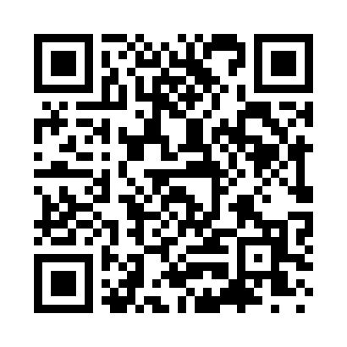
Prayer times for Albany Center, Vermont, USA
Mon 1 Apr 2024 - Tue 30 Apr 2024
High Latitude Method: Angle Based Rule
Prayer Calculation Method: Islamic Society of North America
Asar Calculation Method: Shafi

Date | Day | Fajr | Sunrise | Dhuhr | Asr | Maghrib | Isha
1 | Mon | 5:06 | 6:29 | 12:53 | 4:28 | 7:18 | 8:41
2 | Tue | 5:04 | 6:27 | 12:53 | 4:29 | 7:19 | 8:42
3 | Wed | 5:02 | 6:26 | 12:52 | 4:29 | 7:20 | 8:44
4 | Thu | 5:00 | 6:24 | 12:52 | 4:30 | 7:21 | 8:45
5 | Fri | 4:58 | 6:22 | 12:52 | 4:30 | 7:23 | 8:47
6 | Sat | 4:56 | 6:20 | 12:52 | 4:31 | 7:24 | 8:48
7 | Sun | 4:54 | 6:18 | 12:51 | 4:31 | 7:25 | 8:50
8 | Mon | 4:52 | 6:16 | 12:51 | 4:32 | 7:26 | 8:51
9 | Tue | 4:50 | 6:15 | 12:51 | 4:32 | 7:28 | 8:53
10 | Wed | 4:48 | 6:13 | 12:51 | 4:33 | 7:29 | 8:54
11 | Thu | 4:46 | 6:11 | 12:50 | 4:34 | 7:30 | 8:56
12 | Fri | 4:44 | 6:09 | 12:50 | 4:34 | 7:31 | 8:58
13 | Sat | 4:41 | 6:08 | 12:50 | 4:34 | 7:33 | 8:59
14 | Sun | 4:39 | 6:06 | 12:50 | 4:35 | 7:34 | 9:01
15 | Mon | 4:37 | 6:04 | 12:49 | 4:35 | 7:35 | 9:02
16 | Tue | 4:35 | 6:02 | 12:49 | 4:36 | 7:36 | 9:04
17 | Wed | 4:33 | 6:01 | 12:49 | 4:36 | 7:38 | 9:06
18 | Thu | 4:31 | 5:59 | 12:49 | 4:37 | 7:39 | 9:07
19 | Fri | 4:29 | 5:57 | 12:48 | 4:37 | 7:40 | 9:09
20 | Sat | 4:27 | 5:56 | 12:48 | 4:38 | 7:41 | 9:10
21 | Sun | 4:25 | 5:54 | 12:48 | 4:38 | 7:43 | 9:12
22 | Mon | 4:23 | 5:52 | 12:48 | 4:39 | 7:44 | 9:14
23 | Tue | 4:21 | 5:51 | 12:48 | 4:39 | 7:45 | 9:15
24 | Wed | 4:19 | 5:49 | 12:47 | 4:40 | 7:46 | 9:17
25 | Thu | 4:17 | 5:48 | 12:47 | 4:40 | 7:48 | 9:19
26 | Fri | 4:15 | 5:46 | 12:47 | 4:40 | 7:49 | 9:21
27 | Sat | 4:13 | 5:44 | 12:47 | 4:41 | 7:50 | 9:22
28 | Sun | 4:11 | 5:43 | 12:47 | 4:41 | 7:51 | 9:24
29 | Mon | 4:09 | 5:41 | 12:47 | 4:42 | 7:53 | 9:26
30 | Tue | 4:07 | 5:40 | 12:47 | 4:42 | 7:54 | 9:27
Prayer times provided by https://www.salahtimes.com

