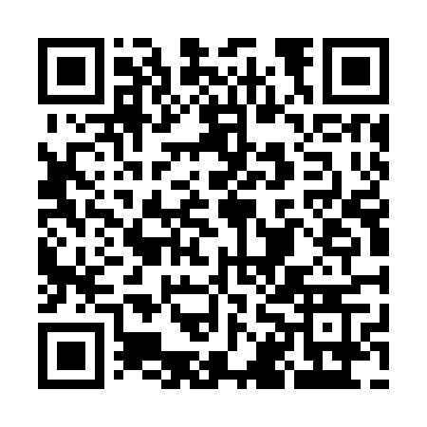
Prayer times for Crowsnest Pass, Alberta, Canada
Wed 1 May 2024 - Fri 31 May 2024
High Latitude Method: Angle Based Rule
Prayer Calculation Method: Islamic Society of North America
Asar Calculation Method: Hanafi

Date | Day | Fajr | Sunrise | Dhuhr | Asr | Maghrib | Isha
1 | Wed | 4:26 | 6:14 | 1:35 | 6:41 | 8:57 | 10:46
2 | Thu | 4:23 | 6:13 | 1:35 | 6:41 | 8:58 | 10:48
3 | Fri | 4:21 | 6:11 | 1:35 | 6:42 | 9:00 | 10:50
4 | Sat | 4:18 | 6:09 | 1:35 | 6:43 | 9:01 | 10:53
5 | Sun | 4:15 | 6:08 | 1:35 | 6:44 | 9:03 | 10:55
6 | Mon | 4:13 | 6:06 | 1:35 | 6:45 | 9:04 | 10:58
7 | Tue | 4:10 | 6:04 | 1:35 | 6:46 | 9:06 | 11:00
8 | Wed | 4:08 | 6:03 | 1:35 | 6:47 | 9:07 | 11:02
9 | Thu | 4:05 | 6:01 | 1:34 | 6:48 | 9:08 | 11:05
10 | Fri | 4:03 | 6:00 | 1:34 | 6:49 | 9:10 | 11:07
11 | Sat | 4:01 | 5:58 | 1:34 | 6:49 | 9:11 | 11:10
12 | Sun | 3:58 | 5:57 | 1:34 | 6:50 | 9:13 | 11:12
13 | Mon | 3:56 | 5:55 | 1:34 | 6:51 | 9:14 | 11:14
14 | Tue | 3:53 | 5:54 | 1:34 | 6:52 | 9:15 | 11:17
15 | Wed | 3:51 | 5:53 | 1:34 | 6:53 | 9:17 | 11:19
16 | Thu | 3:48 | 5:51 | 1:34 | 6:54 | 9:18 | 11:22
17 | Fri | 3:46 | 5:50 | 1:34 | 6:54 | 9:20 | 11:24
18 | Sat | 3:44 | 5:49 | 1:35 | 6:55 | 9:21 | 11:27
19 | Sun | 3:41 | 5:48 | 1:35 | 6:56 | 9:22 | 11:29
20 | Mon | 3:41 | 5:46 | 1:35 | 6:57 | 9:24 | 11:29
21 | Tue | 3:40 | 5:45 | 1:35 | 6:57 | 9:25 | 11:30
22 | Wed | 3:40 | 5:44 | 1:35 | 6:58 | 9:26 | 11:31
23 | Thu | 3:39 | 5:43 | 1:35 | 6:59 | 9:27 | 11:31
24 | Fri | 3:39 | 5:42 | 1:35 | 7:00 | 9:28 | 11:32
25 | Sat | 3:38 | 5:41 | 1:35 | 7:00 | 9:30 | 11:32
26 | Sun | 3:38 | 5:40 | 1:35 | 7:01 | 9:31 | 11:33
27 | Mon | 3:37 | 5:39 | 1:35 | 7:02 | 9:32 | 11:34
28 | Tue | 3:37 | 5:38 | 1:35 | 7:02 | 9:33 | 11:34
29 | Wed | 3:37 | 5:37 | 1:36 | 7:03 | 9:34 | 11:35
30 | Thu | 3:36 | 5:37 | 1:36 | 7:04 | 9:35 | 11:36
31 | Fri | 3:36 | 5:36 | 1:36 | 7:04 | 9:36 | 11:36
Prayer times provided by https://www.salahtimes.com

