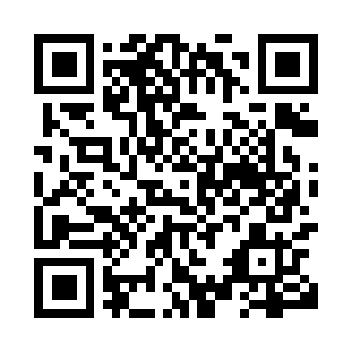
Prayer times for Bear Canyon, Alberta, Canada
Mon 1 Jul 2024 - Wed 31 Jul 2024
High Latitude Method: Angle Based Rule
Prayer Calculation Method: Islamic Society of North America
Asar Calculation Method: Hanafi

Date | Day | Fajr | Sunrise | Dhuhr | Asr | Maghrib | Isha
1 | Mon | 3:40 | 5:17 | 2:03 | 7:51 | 10:50 | 12:26
2 | Tue | 3:41 | 5:18 | 2:04 | 7:51 | 10:49 | 12:26
3 | Wed | 3:41 | 5:19 | 2:04 | 7:51 | 10:48 | 12:26
4 | Thu | 3:42 | 5:20 | 2:04 | 7:50 | 10:48 | 12:26
5 | Fri | 3:42 | 5:21 | 2:04 | 7:50 | 10:47 | 12:25
6 | Sat | 3:43 | 5:22 | 2:04 | 7:50 | 10:46 | 12:25
7 | Sun | 3:44 | 5:23 | 2:04 | 7:49 | 10:45 | 12:25
8 | Mon | 3:44 | 5:24 | 2:05 | 7:49 | 10:44 | 12:24
9 | Tue | 3:45 | 5:26 | 2:05 | 7:49 | 10:43 | 12:24
10 | Wed | 3:46 | 5:27 | 2:05 | 7:48 | 10:42 | 12:23
11 | Thu | 3:46 | 5:28 | 2:05 | 7:48 | 10:41 | 12:23
12 | Fri | 3:47 | 5:30 | 2:05 | 7:47 | 10:40 | 12:22
13 | Sat | 3:48 | 5:31 | 2:05 | 7:47 | 10:39 | 12:22
14 | Sun | 3:49 | 5:33 | 2:05 | 7:46 | 10:37 | 12:21
15 | Mon | 3:50 | 5:34 | 2:05 | 7:45 | 10:36 | 12:20
16 | Tue | 3:50 | 5:36 | 2:05 | 7:45 | 10:35 | 12:20
17 | Wed | 3:51 | 5:37 | 2:06 | 7:44 | 10:33 | 12:19
18 | Thu | 3:52 | 5:39 | 2:06 | 7:43 | 10:32 | 12:18
19 | Fri | 3:53 | 5:40 | 2:06 | 7:42 | 10:30 | 12:18
20 | Sat | 3:54 | 5:42 | 2:06 | 7:42 | 10:29 | 12:17
21 | Sun | 3:55 | 5:44 | 2:06 | 7:41 | 10:27 | 12:16
22 | Mon | 3:55 | 5:45 | 2:06 | 7:40 | 10:25 | 12:15
23 | Tue | 3:56 | 5:47 | 2:06 | 7:39 | 10:24 | 12:14
24 | Wed | 3:57 | 5:49 | 2:06 | 7:38 | 10:22 | 12:14
25 | Thu | 3:58 | 5:51 | 2:06 | 7:37 | 10:20 | 12:13
26 | Fri | 3:59 | 5:53 | 2:06 | 7:36 | 10:18 | 12:12
27 | Sat | 4:00 | 5:54 | 2:06 | 7:35 | 10:16 | 12:11
28 | Sun | 4:01 | 5:56 | 2:06 | 7:34 | 10:14 | 12:10
29 | Mon | 4:02 | 5:58 | 2:06 | 7:33 | 10:12 | 12:09
30 | Tue | 4:03 | 6:00 | 2:06 | 7:32 | 10:10 | 12:08
31 | Wed | 4:03 | 6:02 | 2:06 | 7:30 | 10:08 | 12:07
Prayer times provided by https://www.salahtimes.com

