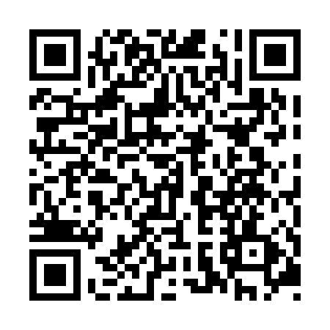

**Prayer times for Utimiskinau Astach, Quebec, Canada**

**Wed 1 Jan 2025 - Fri 31 Jan 2025**

**High Latitude Method: Angle Based Rule**

**Prayer Calculation Method: Islamic Society of North America**

**Asar Calculation Method: Hanafi**

|  |  |  |  |  |  |  |  |
| --- | --- | --- | --- | --- | --- | --- | --- |
| **Date** | **Day** | **Fajr** | **Sunrise** | **Dhuhr** | **Asr** | **Maghrib** | **Isha** |
| 1 | Wed | 6:17 | 8:15 | 11:48 | 1:33 | 3:21 | 5:20 |
| 2 | Thu | 6:17 | 8:15 | 11:48 | 1:34 | 3:22 | 5:21 |
| 3 | Fri | 6:17 | 8:15 | 11:49 | 1:35 | 3:24 | 5:22 |
| 4 | Sat | 6:16 | 8:14 | 11:49 | 1:36 | 3:25 | 5:23 |
| 5 | Sun | 6:16 | 8:14 | 11:50 | 1:38 | 3:26 | 5:24 |
| 6 | Mon | 6:16 | 8:13 | 11:50 | 1:39 | 3:28 | 5:25 |
| 7 | Tue | 6:15 | 8:13 | 11:51 | 1:40 | 3:29 | 5:26 |
| 8 | Wed | 6:15 | 8:12 | 11:51 | 1:42 | 3:31 | 5:28 |
| 9 | Thu | 6:15 | 8:11 | 11:52 | 1:43 | 3:33 | 5:29 |
| 10 | Fri | 6:14 | 8:10 | 11:52 | 1:45 | 3:34 | 5:30 |
| 11 | Sat | 6:14 | 8:09 | 11:52 | 1:46 | 3:36 | 5:32 |
| 12 | Sun | 6:13 | 8:08 | 11:53 | 1:48 | 3:38 | 5:33 |
| 13 | Mon | 6:12 | 8:07 | 11:53 | 1:50 | 3:40 | 5:34 |
| 14 | Tue | 6:12 | 8:06 | 11:53 | 1:51 | 3:41 | 5:36 |
| 15 | Wed | 6:11 | 8:05 | 11:54 | 1:53 | 3:43 | 5:37 |
| 16 | Thu | 6:10 | 8:04 | 11:54 | 1:55 | 3:45 | 5:39 |
| 17 | Fri | 6:09 | 8:03 | 11:54 | 1:57 | 3:47 | 5:40 |
| 18 | Sat | 6:08 | 8:01 | 11:55 | 1:58 | 3:49 | 5:42 |
| 19 | Sun | 6:07 | 8:00 | 11:55 | 2:00 | 3:51 | 5:44 |
| 20 | Mon | 6:06 | 7:59 | 11:55 | 2:02 | 3:53 | 5:45 |
| 21 | Tue | 6:05 | 7:57 | 11:56 | 2:04 | 3:55 | 5:47 |
| 22 | Wed | 6:04 | 7:56 | 11:56 | 2:06 | 3:57 | 5:48 |
| 23 | Thu | 6:03 | 7:54 | 11:56 | 2:08 | 3:59 | 5:50 |
| 24 | Fri | 6:02 | 7:53 | 11:56 | 2:10 | 4:01 | 5:52 |
| 25 | Sat | 6:01 | 7:51 | 11:57 | 2:11 | 4:03 | 5:54 |
| 26 | Sun | 5:59 | 7:49 | 11:57 | 2:13 | 4:05 | 5:55 |
| 27 | Mon | 5:58 | 7:48 | 11:57 | 2:15 | 4:07 | 5:57 |
| 28 | Tue | 5:57 | 7:46 | 11:57 | 2:17 | 4:10 | 5:59 |
| 29 | Wed | 5:55 | 7:44 | 11:57 | 2:19 | 4:12 | 6:01 |
| 30 | Thu | 5:54 | 7:42 | 11:58 | 2:21 | 4:14 | 6:02 |
| 31 | Fri | 5:52 | 7:40 | 11:58 | 2:23 | 4:16 | 6:04 |

**Prayer times provided by https://www.salahtimes.com**