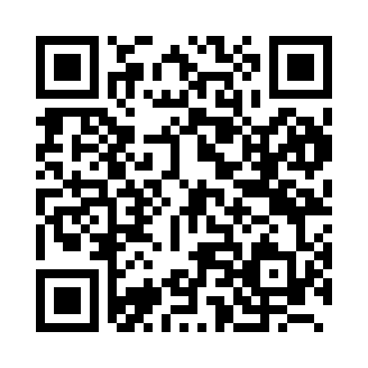

**Prayer times for Dunedin, New Zealand**

**Fri 1 Nov 2024 - Sat 30 Nov 2024**

**High Latitude Method: None**

**Prayer Calculation Method: Muslim World League**

**Asar Calculation Method: Shafi**

|  |  |  |  |  |  |  |  |
| --- | --- | --- | --- | --- | --- | --- | --- |
| **Date** | **Day** | **Fajr** | **Sunrise** | **Dhuhr** | **Asr** | **Maghrib** | **Isha** |
| 1 | Fri | 4:16 | 6:15 | 1:22 | 5:17 | 8:29 | 10:20 |
| 2 | Sat | 4:14 | 6:13 | 1:22 | 5:18 | 8:30 | 10:22 |
| 3 | Sun | 4:12 | 6:12 | 1:22 | 5:19 | 8:32 | 10:24 |
| 4 | Mon | 4:09 | 6:10 | 1:22 | 5:19 | 8:33 | 10:27 |
| 5 | Tue | 4:07 | 6:09 | 1:22 | 5:20 | 8:35 | 10:29 |
| 6 | Wed | 4:05 | 6:08 | 1:22 | 5:20 | 8:36 | 10:31 |
| 7 | Thu | 4:03 | 6:06 | 1:22 | 5:21 | 8:38 | 10:33 |
| 8 | Fri | 4:00 | 6:05 | 1:22 | 5:22 | 8:39 | 10:35 |
| 9 | Sat | 3:58 | 6:04 | 1:22 | 5:22 | 8:41 | 10:38 |
| 10 | Sun | 3:56 | 6:02 | 1:22 | 5:23 | 8:42 | 10:40 |
| 11 | Mon | 3:54 | 6:01 | 1:22 | 5:23 | 8:44 | 10:42 |
| 12 | Tue | 3:52 | 6:00 | 1:22 | 5:24 | 8:45 | 10:45 |
| 13 | Wed | 3:49 | 5:59 | 1:22 | 5:25 | 8:46 | 10:47 |
| 14 | Thu | 3:47 | 5:58 | 1:22 | 5:25 | 8:48 | 10:49 |
| 15 | Fri | 3:45 | 5:56 | 1:23 | 5:26 | 8:49 | 10:51 |
| 16 | Sat | 3:43 | 5:55 | 1:23 | 5:26 | 8:51 | 10:54 |
| 17 | Sun | 3:41 | 5:54 | 1:23 | 5:27 | 8:52 | 10:56 |
| 18 | Mon | 3:39 | 5:53 | 1:23 | 5:28 | 8:54 | 10:58 |
| 19 | Tue | 3:37 | 5:52 | 1:23 | 5:28 | 8:55 | 11:01 |
| 20 | Wed | 3:35 | 5:51 | 1:24 | 5:29 | 8:56 | 11:03 |
| 21 | Thu | 3:33 | 5:51 | 1:24 | 5:29 | 8:58 | 11:05 |
| 22 | Fri | 3:31 | 5:50 | 1:24 | 5:30 | 8:59 | 11:08 |
| 23 | Sat | 3:29 | 5:49 | 1:24 | 5:31 | 9:00 | 11:10 |
| 24 | Sun | 3:27 | 5:48 | 1:25 | 5:31 | 9:02 | 11:12 |
| 25 | Mon | 3:25 | 5:47 | 1:25 | 5:32 | 9:03 | 11:14 |
| 26 | Tue | 3:24 | 5:47 | 1:25 | 5:33 | 9:04 | 11:17 |
| 27 | Wed | 3:22 | 5:46 | 1:26 | 5:33 | 9:06 | 11:19 |
| 28 | Thu | 3:20 | 5:45 | 1:26 | 5:34 | 9:07 | 11:21 |
| 29 | Fri | 3:18 | 5:45 | 1:26 | 5:34 | 9:08 | 11:23 |
| 30 | Sat | 3:17 | 5:44 | 1:27 | 5:35 | 9:09 | 11:25 |

**Prayer times provided by https://www.salahtimes.com**