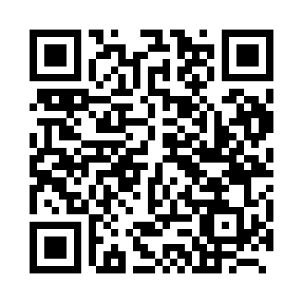

**Prayer times for Vitebsk, Belarus**

**Fri 1 Nov 2024 - Sat 30 Nov 2024**

**High Latitude Method: Angle Based Rule**

**Prayer Calculation Method: Muslim World League**

**Asar Calculation Method: Shafi**

|  |  |  |  |  |  |  |  |
| --- | --- | --- | --- | --- | --- | --- | --- |
| **Date** | **Day** | **Fajr** | **Sunrise** | **Dhuhr** | **Asr** | **Maghrib** | **Isha** |
| 1 | Fri | 6:00 | 8:04 | 12:43 | 2:52 | 5:21 | 7:18 |
| 2 | Sat | 6:02 | 8:06 | 12:43 | 2:50 | 5:19 | 7:16 |
| 3 | Sun | 6:04 | 8:08 | 12:43 | 2:49 | 5:17 | 7:14 |
| 4 | Mon | 6:05 | 8:10 | 12:43 | 2:47 | 5:14 | 7:13 |
| 5 | Tue | 6:07 | 8:12 | 12:43 | 2:46 | 5:13 | 7:11 |
| 6 | Wed | 6:09 | 8:15 | 12:43 | 2:44 | 5:11 | 7:09 |
| 7 | Thu | 6:11 | 8:17 | 12:43 | 2:43 | 5:09 | 7:08 |
| 8 | Fri | 6:12 | 8:19 | 12:43 | 2:41 | 5:07 | 7:06 |
| 9 | Sat | 6:14 | 8:21 | 12:43 | 2:40 | 5:05 | 7:05 |
| 10 | Sun | 6:16 | 8:23 | 12:43 | 2:39 | 5:03 | 7:03 |
| 11 | Mon | 6:17 | 8:25 | 12:43 | 2:37 | 5:01 | 7:02 |
| 12 | Tue | 6:19 | 8:27 | 12:44 | 2:36 | 5:00 | 7:00 |
| 13 | Wed | 6:21 | 8:29 | 12:44 | 2:35 | 4:58 | 6:59 |
| 14 | Thu | 6:22 | 8:31 | 12:44 | 2:33 | 4:56 | 6:58 |
| 15 | Fri | 6:24 | 8:33 | 12:44 | 2:32 | 4:54 | 6:56 |
| 16 | Sat | 6:25 | 8:35 | 12:44 | 2:31 | 4:53 | 6:55 |
| 17 | Sun | 6:27 | 8:37 | 12:44 | 2:30 | 4:51 | 6:54 |
| 18 | Mon | 6:29 | 8:39 | 12:45 | 2:29 | 4:50 | 6:53 |
| 19 | Tue | 6:30 | 8:41 | 12:45 | 2:28 | 4:48 | 6:52 |
| 20 | Wed | 6:32 | 8:42 | 12:45 | 2:27 | 4:47 | 6:51 |
| 21 | Thu | 6:33 | 8:44 | 12:45 | 2:26 | 4:46 | 6:50 |
| 22 | Fri | 6:35 | 8:46 | 12:46 | 2:25 | 4:44 | 6:49 |
| 23 | Sat | 6:36 | 8:48 | 12:46 | 2:24 | 4:43 | 6:48 |
| 24 | Sun | 6:38 | 8:50 | 12:46 | 2:23 | 4:42 | 6:47 |
| 25 | Mon | 6:39 | 8:52 | 12:46 | 2:22 | 4:41 | 6:46 |
| 26 | Tue | 6:40 | 8:53 | 12:47 | 2:21 | 4:39 | 6:45 |
| 27 | Wed | 6:42 | 8:55 | 12:47 | 2:21 | 4:38 | 6:45 |
| 28 | Thu | 6:43 | 8:57 | 12:47 | 2:20 | 4:37 | 6:44 |
| 29 | Fri | 6:44 | 8:59 | 12:48 | 2:19 | 4:36 | 6:44 |
| 30 | Sat | 6:46 | 9:00 | 12:48 | 2:19 | 4:36 | 6:43 |

**Prayer times provided by https://www.salahtimes.com**