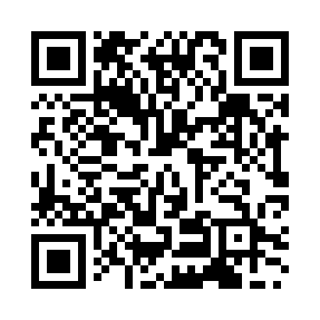
Prayer times for Izumisano, Japan
Wed 1 May 2024 - Fri 31 May 2024
High Latitude Method: None
Prayer Calculation Method: Muslim World League
Asar Calculation Method: Shafi

Date | Day | Fajr | Sunrise | Dhuhr | Asr | Maghrib | Isha
1 | Wed | 3:36 | 5:09 | 11:56 | 3:39 | 6:43 | 8:10
2 | Thu | 3:35 | 5:08 | 11:56 | 3:39 | 6:44 | 8:11
3 | Fri | 3:33 | 5:07 | 11:56 | 3:39 | 6:45 | 8:13
4 | Sat | 3:32 | 5:06 | 11:55 | 3:39 | 6:45 | 8:14
5 | Sun | 3:31 | 5:05 | 11:55 | 3:39 | 6:46 | 8:15
6 | Mon | 3:29 | 5:04 | 11:55 | 3:39 | 6:47 | 8:16
7 | Tue | 3:28 | 5:03 | 11:55 | 3:39 | 6:48 | 8:17
8 | Wed | 3:27 | 5:02 | 11:55 | 3:39 | 6:49 | 8:18
9 | Thu | 3:26 | 5:01 | 11:55 | 3:40 | 6:49 | 8:19
10 | Fri | 3:24 | 5:00 | 11:55 | 3:40 | 6:50 | 8:20
11 | Sat | 3:23 | 5:00 | 11:55 | 3:40 | 6:51 | 8:21
12 | Sun | 3:22 | 4:59 | 11:55 | 3:40 | 6:52 | 8:22
13 | Mon | 3:21 | 4:58 | 11:55 | 3:40 | 6:53 | 8:23
14 | Tue | 3:20 | 4:57 | 11:55 | 3:40 | 6:53 | 8:25
15 | Wed | 3:19 | 4:56 | 11:55 | 3:40 | 6:54 | 8:26
16 | Thu | 3:18 | 4:56 | 11:55 | 3:40 | 6:55 | 8:27
17 | Fri | 3:17 | 4:55 | 11:55 | 3:40 | 6:56 | 8:28
18 | Sat | 3:16 | 4:54 | 11:55 | 3:40 | 6:56 | 8:29
19 | Sun | 3:15 | 4:54 | 11:55 | 3:41 | 6:57 | 8:30
20 | Mon | 3:14 | 4:53 | 11:55 | 3:41 | 6:58 | 8:31
21 | Tue | 3:13 | 4:52 | 11:55 | 3:41 | 6:59 | 8:32
22 | Wed | 3:12 | 4:52 | 11:55 | 3:41 | 6:59 | 8:33
23 | Thu | 3:11 | 4:51 | 11:55 | 3:41 | 7:00 | 8:34
24 | Fri | 3:10 | 4:51 | 11:56 | 3:41 | 7:01 | 8:35
25 | Sat | 3:09 | 4:50 | 11:56 | 3:41 | 7:01 | 8:36
26 | Sun | 3:09 | 4:50 | 11:56 | 3:42 | 7:02 | 8:37
27 | Mon | 3:08 | 4:49 | 11:56 | 3:42 | 7:03 | 8:38
28 | Tue | 3:07 | 4:49 | 11:56 | 3:42 | 7:03 | 8:39
29 | Wed | 3:06 | 4:49 | 11:56 | 3:42 | 7:04 | 8:40
30 | Thu | 3:06 | 4:48 | 11:56 | 3:42 | 7:05 | 8:40
31 | Fri | 3:05 | 4:48 | 11:56 | 3:42 | 7:05 | 8:41
Prayer times provided by https://www.salahtimes.com

