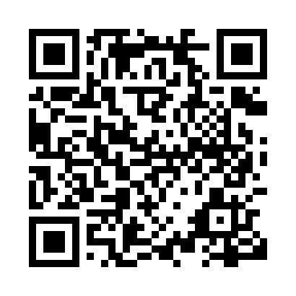
Prayer times for Fort Smith, Northwest Territories, Canada
Wed 1 May 2024 - Fri 31 May 2024
High Latitude Method: Angle Based Rule
Prayer Calculation Method: Islamic Society of North America
Asar Calculation Method: Hanafi

Date | Day | Fajr | Sunrise | Dhuhr | Asr | Maghrib | Isha
1 | Wed | 3:24 | 5:23 | 1:25 | 6:43 | 9:27 | 11:26
2 | Thu | 3:23 | 5:21 | 1:24 | 6:44 | 9:30 | 11:27
3 | Fri | 3:21 | 5:18 | 1:24 | 6:46 | 9:32 | 11:29
4 | Sat | 3:20 | 5:15 | 1:24 | 6:47 | 9:35 | 11:30
5 | Sun | 3:19 | 5:13 | 1:24 | 6:48 | 9:37 | 11:31
6 | Mon | 3:17 | 5:10 | 1:24 | 6:50 | 9:39 | 11:32
7 | Tue | 3:16 | 5:07 | 1:24 | 6:51 | 9:42 | 11:33
8 | Wed | 3:15 | 5:05 | 1:24 | 6:53 | 9:44 | 11:35
9 | Thu | 3:13 | 5:02 | 1:24 | 6:54 | 9:47 | 11:36
10 | Fri | 3:12 | 5:00 | 1:24 | 6:55 | 9:49 | 11:37
11 | Sat | 3:11 | 4:57 | 1:24 | 6:57 | 9:52 | 11:38
12 | Sun | 3:10 | 4:55 | 1:24 | 6:58 | 9:54 | 11:39
13 | Mon | 3:09 | 4:53 | 1:24 | 6:59 | 9:56 | 11:40
14 | Tue | 3:07 | 4:50 | 1:24 | 7:00 | 9:59 | 11:42
15 | Wed | 3:06 | 4:48 | 1:24 | 7:02 | 10:01 | 11:43
16 | Thu | 3:05 | 4:46 | 1:24 | 7:03 | 10:03 | 11:44
17 | Fri | 3:04 | 4:43 | 1:24 | 7:04 | 10:06 | 11:45
18 | Sat | 3:03 | 4:41 | 1:24 | 7:05 | 10:08 | 11:46
19 | Sun | 3:02 | 4:39 | 1:24 | 7:07 | 10:10 | 11:47
20 | Mon | 3:01 | 4:37 | 1:24 | 7:08 | 10:12 | 11:49
21 | Tue | 3:00 | 4:35 | 1:24 | 7:09 | 10:15 | 11:50
22 | Wed | 2:59 | 4:33 | 1:24 | 7:10 | 10:17 | 11:51
23 | Thu | 2:58 | 4:31 | 1:24 | 7:11 | 10:19 | 11:52
24 | Fri | 2:57 | 4:29 | 1:24 | 7:12 | 10:21 | 11:53
25 | Sat | 2:56 | 4:27 | 1:25 | 7:13 | 10:23 | 11:54
26 | Sun | 2:55 | 4:25 | 1:25 | 7:14 | 10:25 | 11:55
27 | Mon | 2:54 | 4:23 | 1:25 | 7:15 | 10:27 | 11:56
28 | Tue | 2:54 | 4:22 | 1:25 | 7:16 | 10:29 | 11:57
29 | Wed | 2:53 | 4:20 | 1:25 | 7:17 | 10:31 | 11:58
30 | Thu | 2:52 | 4:18 | 1:25 | 7:18 | 10:33 | 11:59
31 | Fri | 2:51 | 4:17 | 1:25 | 7:19 | 10:35 | 12:00
Prayer times provided by https://www.salahtimes.com

