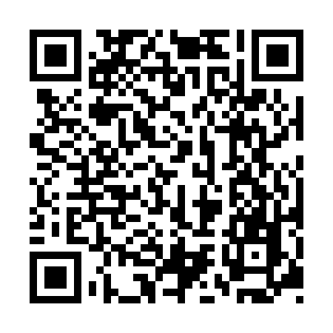
Prayer times for Barig-Selbenhausen, Germany
Mon 1 Apr 2024 - Tue 30 Apr 2024
High Latitude Method: Angle Based Rule
Prayer Calculation Method: Muslim World League
Asar Calculation Method: Shafi

Date | Day | Fajr | Sunrise | Dhuhr | Asr | Maghrib | Isha
1 | Mon | 5:07 | 7:03 | 1:31 | 5:04 | 8:00 | 9:49
2 | Tue | 5:04 | 7:00 | 1:31 | 5:05 | 8:02 | 9:51
3 | Wed | 5:02 | 6:58 | 1:30 | 5:06 | 8:03 | 9:53
4 | Thu | 4:59 | 6:56 | 1:30 | 5:07 | 8:05 | 9:55
5 | Fri | 4:56 | 6:54 | 1:30 | 5:08 | 8:07 | 9:57
6 | Sat | 4:53 | 6:52 | 1:29 | 5:09 | 8:08 | 9:59
7 | Sun | 4:50 | 6:50 | 1:29 | 5:09 | 8:10 | 10:02
8 | Mon | 4:48 | 6:47 | 1:29 | 5:10 | 8:11 | 10:04
9 | Tue | 4:45 | 6:45 | 1:29 | 5:11 | 8:13 | 10:06
10 | Wed | 4:42 | 6:43 | 1:28 | 5:12 | 8:15 | 10:08
11 | Thu | 4:39 | 6:41 | 1:28 | 5:12 | 8:16 | 10:10
12 | Fri | 4:36 | 6:39 | 1:28 | 5:13 | 8:18 | 10:13
13 | Sat | 4:33 | 6:37 | 1:28 | 5:14 | 8:19 | 10:15
14 | Sun | 4:30 | 6:35 | 1:27 | 5:15 | 8:21 | 10:17
15 | Mon | 4:28 | 6:33 | 1:27 | 5:15 | 8:23 | 10:20
16 | Tue | 4:25 | 6:30 | 1:27 | 5:16 | 8:24 | 10:22
17 | Wed | 4:22 | 6:28 | 1:27 | 5:17 | 8:26 | 10:24
18 | Thu | 4:19 | 6:26 | 1:26 | 5:18 | 8:27 | 10:27
19 | Fri | 4:16 | 6:24 | 1:26 | 5:18 | 8:29 | 10:29
20 | Sat | 4:13 | 6:22 | 1:26 | 5:19 | 8:31 | 10:32
21 | Sun | 4:10 | 6:20 | 1:26 | 5:20 | 8:32 | 10:34
22 | Mon | 4:07 | 6:18 | 1:26 | 5:20 | 8:34 | 10:37
23 | Tue | 4:04 | 6:16 | 1:25 | 5:21 | 8:35 | 10:39
24 | Wed | 4:00 | 6:14 | 1:25 | 5:22 | 8:37 | 10:42
25 | Thu | 3:57 | 6:12 | 1:25 | 5:22 | 8:39 | 10:45
26 | Fri | 3:54 | 6:11 | 1:25 | 5:23 | 8:40 | 10:47
27 | Sat | 3:51 | 6:09 | 1:25 | 5:24 | 8:42 | 10:50
28 | Sun | 3:48 | 6:07 | 1:25 | 5:24 | 8:43 | 10:53
29 | Mon | 3:45 | 6:05 | 1:24 | 5:25 | 8:45 | 10:55
30 | Tue | 3:42 | 6:03 | 1:24 | 5:26 | 8:46 | 10:58
Prayer times provided by https://www.salahtimes.com

