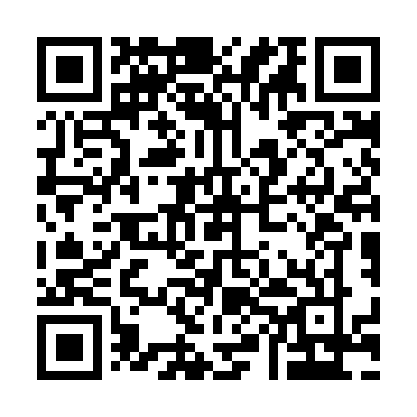

**Prayer times for Border Beacon, Quebec, Canada**

**Wed 1 Jan 2025 - Fri 31 Jan 2025**

**High Latitude Method: Angle Based Rule**

**Prayer Calculation Method: Islamic Society of North America**

**Asar Calculation Method: Hanafi**

|  |  |  |  |  |  |  |  |
| --- | --- | --- | --- | --- | --- | --- | --- |
| **Date** | **Day** | **Fajr** | **Sunrise** | **Dhuhr** | **Asr** | **Maghrib** | **Isha** |
| 1 | Wed | 5:45 | 7:41 | 11:18 | 1:08 | 2:56 | 4:52 |
| 2 | Thu | 5:45 | 7:41 | 11:19 | 1:09 | 2:57 | 4:53 |
| 3 | Fri | 5:45 | 7:40 | 11:19 | 1:10 | 2:59 | 4:54 |
| 4 | Sat | 5:45 | 7:40 | 11:20 | 1:12 | 3:00 | 4:55 |
| 5 | Sun | 5:45 | 7:40 | 11:20 | 1:13 | 3:02 | 4:56 |
| 6 | Mon | 5:45 | 7:39 | 11:21 | 1:14 | 3:03 | 4:57 |
| 7 | Tue | 5:44 | 7:38 | 11:21 | 1:16 | 3:04 | 4:59 |
| 8 | Wed | 5:44 | 7:38 | 11:22 | 1:17 | 3:06 | 5:00 |
| 9 | Thu | 5:43 | 7:37 | 11:22 | 1:18 | 3:08 | 5:01 |
| 10 | Fri | 5:43 | 7:36 | 11:22 | 1:20 | 3:09 | 5:02 |
| 11 | Sat | 5:42 | 7:35 | 11:23 | 1:22 | 3:11 | 5:04 |
| 12 | Sun | 5:42 | 7:34 | 11:23 | 1:23 | 3:13 | 5:05 |
| 13 | Mon | 5:41 | 7:34 | 11:24 | 1:25 | 3:14 | 5:06 |
| 14 | Tue | 5:40 | 7:32 | 11:24 | 1:26 | 3:16 | 5:08 |
| 15 | Wed | 5:40 | 7:31 | 11:24 | 1:28 | 3:18 | 5:09 |
| 16 | Thu | 5:39 | 7:30 | 11:25 | 1:30 | 3:20 | 5:11 |
| 17 | Fri | 5:38 | 7:29 | 11:25 | 1:31 | 3:21 | 5:12 |
| 18 | Sat | 5:37 | 7:28 | 11:25 | 1:33 | 3:23 | 5:14 |
| 19 | Sun | 5:36 | 7:27 | 11:26 | 1:35 | 3:25 | 5:15 |
| 20 | Mon | 5:35 | 7:25 | 11:26 | 1:37 | 3:27 | 5:17 |
| 21 | Tue | 5:34 | 7:24 | 11:26 | 1:39 | 3:29 | 5:19 |
| 22 | Wed | 5:33 | 7:22 | 11:26 | 1:40 | 3:31 | 5:20 |
| 23 | Thu | 5:32 | 7:21 | 11:27 | 1:42 | 3:33 | 5:22 |
| 24 | Fri | 5:31 | 7:19 | 11:27 | 1:44 | 3:35 | 5:23 |
| 25 | Sat | 5:30 | 7:18 | 11:27 | 1:46 | 3:37 | 5:25 |
| 26 | Sun | 5:29 | 7:16 | 11:27 | 1:48 | 3:39 | 5:27 |
| 27 | Mon | 5:27 | 7:15 | 11:28 | 1:50 | 3:41 | 5:28 |
| 28 | Tue | 5:26 | 7:13 | 11:28 | 1:52 | 3:43 | 5:30 |
| 29 | Wed | 5:25 | 7:11 | 11:28 | 1:54 | 3:45 | 5:32 |
| 30 | Thu | 5:23 | 7:10 | 11:28 | 1:56 | 3:47 | 5:34 |
| 31 | Fri | 5:22 | 7:08 | 11:28 | 1:58 | 3:50 | 5:35 |

**Prayer times provided by https://www.salahtimes.com**