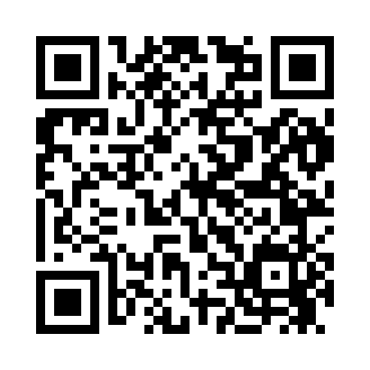
Prayer times for Adams Station, California, USA
Wed 1 May 2024 - Fri 31 May 2024
High Latitude Method: Angle Based Rule
Prayer Calculation Method: Islamic Society of North America
Asar Calculation Method: Shafi

Date | Day | Fajr | Sunrise | Dhuhr | Asr | Maghrib | Isha
1 | Wed | 4:44 | 6:11 | 1:13 | 5:06 | 8:15 | 9:43
2 | Thu | 4:42 | 6:10 | 1:13 | 5:06 | 8:16 | 9:44
3 | Fri | 4:41 | 6:09 | 1:13 | 5:07 | 8:17 | 9:46
4 | Sat | 4:39 | 6:07 | 1:13 | 5:07 | 8:18 | 9:47
5 | Sun | 4:37 | 6:06 | 1:13 | 5:07 | 8:20 | 9:49
6 | Mon | 4:36 | 6:05 | 1:13 | 5:07 | 8:21 | 9:50
7 | Tue | 4:34 | 6:04 | 1:12 | 5:08 | 8:22 | 9:52
8 | Wed | 4:32 | 6:03 | 1:12 | 5:08 | 8:23 | 9:53
9 | Thu | 4:31 | 6:02 | 1:12 | 5:08 | 8:24 | 9:55
10 | Fri | 4:29 | 6:00 | 1:12 | 5:09 | 8:25 | 9:56
11 | Sat | 4:28 | 5:59 | 1:12 | 5:09 | 8:26 | 9:58
12 | Sun | 4:26 | 5:58 | 1:12 | 5:09 | 8:27 | 9:59
13 | Mon | 4:25 | 5:57 | 1:12 | 5:10 | 8:28 | 10:01
14 | Tue | 4:23 | 5:56 | 1:12 | 5:10 | 8:29 | 10:02
15 | Wed | 4:22 | 5:55 | 1:12 | 5:10 | 8:30 | 10:04
16 | Thu | 4:21 | 5:54 | 1:12 | 5:11 | 8:31 | 10:05
17 | Fri | 4:19 | 5:53 | 1:12 | 5:11 | 8:32 | 10:06
18 | Sat | 4:18 | 5:52 | 1:12 | 5:11 | 8:33 | 10:08
19 | Sun | 4:17 | 5:52 | 1:13 | 5:11 | 8:34 | 10:09
20 | Mon | 4:15 | 5:51 | 1:13 | 5:12 | 8:35 | 10:11
21 | Tue | 4:14 | 5:50 | 1:13 | 5:12 | 8:36 | 10:12
22 | Wed | 4:13 | 5:49 | 1:13 | 5:12 | 8:37 | 10:13
23 | Thu | 4:12 | 5:48 | 1:13 | 5:13 | 8:38 | 10:15
24 | Fri | 4:11 | 5:48 | 1:13 | 5:13 | 8:39 | 10:16
25 | Sat | 4:09 | 5:47 | 1:13 | 5:13 | 8:39 | 10:17
26 | Sun | 4:08 | 5:46 | 1:13 | 5:14 | 8:40 | 10:18
27 | Mon | 4:07 | 5:46 | 1:13 | 5:14 | 8:41 | 10:20
28 | Tue | 4:06 | 5:45 | 1:13 | 5:14 | 8:42 | 10:21
29 | Wed | 4:06 | 5:45 | 1:14 | 5:14 | 8:43 | 10:22
30 | Thu | 4:05 | 5:44 | 1:14 | 5:15 | 8:44 | 10:23
31 | Fri | 4:04 | 5:44 | 1:14 | 5:15 | 8:44 | 10:24
Prayer times provided by https://www.salahtimes.com

