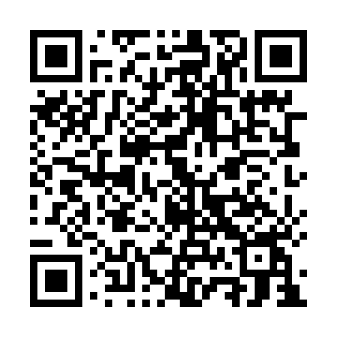

**Prayer times for Quelimane, Mozambique**

**Fri 1 Nov 2024 - Sat 30 Nov 2024**

**High Latitude Method: None**

**Prayer Calculation Method: Muslim World League**

**Asar Calculation Method: Shafi**

|  |  |  |  |  |  |  |  |
| --- | --- | --- | --- | --- | --- | --- | --- |
| **Date** | **Day** | **Fajr** | **Sunrise** | **Dhuhr** | **Asr** | **Maghrib** | **Isha** |
| 1 | Fri | 3:37 | 4:53 | 11:16 | 2:30 | 5:39 | 6:51 |
| 2 | Sat | 3:36 | 4:53 | 11:16 | 2:30 | 5:40 | 6:51 |
| 3 | Sun | 3:36 | 4:52 | 11:16 | 2:29 | 5:40 | 6:52 |
| 4 | Mon | 3:35 | 4:52 | 11:16 | 2:29 | 5:40 | 6:53 |
| 5 | Tue | 3:35 | 4:51 | 11:16 | 2:29 | 5:41 | 6:53 |
| 6 | Wed | 3:34 | 4:51 | 11:16 | 2:28 | 5:41 | 6:54 |
| 7 | Thu | 3:33 | 4:51 | 11:16 | 2:28 | 5:42 | 6:55 |
| 8 | Fri | 3:33 | 4:50 | 11:16 | 2:28 | 5:42 | 6:55 |
| 9 | Sat | 3:32 | 4:50 | 11:16 | 2:27 | 5:43 | 6:56 |
| 10 | Sun | 3:32 | 4:50 | 11:16 | 2:27 | 5:43 | 6:57 |
| 11 | Mon | 3:32 | 4:49 | 11:17 | 2:27 | 5:44 | 6:57 |
| 12 | Tue | 3:31 | 4:49 | 11:17 | 2:26 | 5:44 | 6:58 |
| 13 | Wed | 3:31 | 4:49 | 11:17 | 2:27 | 5:45 | 6:59 |
| 14 | Thu | 3:30 | 4:49 | 11:17 | 2:28 | 5:45 | 6:59 |
| 15 | Fri | 3:30 | 4:48 | 11:17 | 2:29 | 5:46 | 7:00 |
| 16 | Sat | 3:30 | 4:48 | 11:17 | 2:30 | 5:47 | 7:01 |
| 17 | Sun | 3:29 | 4:48 | 11:17 | 2:31 | 5:47 | 7:01 |
| 18 | Mon | 3:29 | 4:48 | 11:18 | 2:31 | 5:48 | 7:02 |
| 19 | Tue | 3:29 | 4:48 | 11:18 | 2:32 | 5:48 | 7:03 |
| 20 | Wed | 3:28 | 4:48 | 11:18 | 2:33 | 5:49 | 7:03 |
| 21 | Thu | 3:28 | 4:48 | 11:18 | 2:34 | 5:49 | 7:04 |
| 22 | Fri | 3:28 | 4:48 | 11:19 | 2:35 | 5:50 | 7:05 |
| 23 | Sat | 3:28 | 4:48 | 11:19 | 2:35 | 5:51 | 7:06 |
| 24 | Sun | 3:28 | 4:48 | 11:19 | 2:36 | 5:51 | 7:06 |
| 25 | Mon | 3:27 | 4:48 | 11:20 | 2:37 | 5:52 | 7:07 |
| 26 | Tue | 3:27 | 4:48 | 11:20 | 2:38 | 5:52 | 7:08 |
| 27 | Wed | 3:27 | 4:48 | 11:20 | 2:38 | 5:53 | 7:09 |
| 28 | Thu | 3:27 | 4:48 | 11:21 | 2:39 | 5:54 | 7:09 |
| 29 | Fri | 3:27 | 4:48 | 11:21 | 2:40 | 5:54 | 7:10 |
| 30 | Sat | 3:27 | 4:48 | 11:21 | 2:41 | 5:55 | 7:11 |

**Prayer times provided by https://www.salahtimes.com**