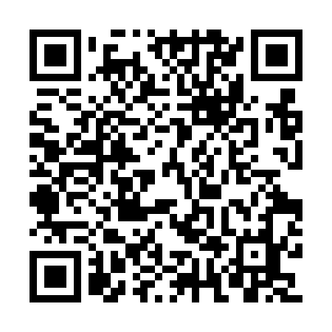

**Prayer times for Nizhny Novgorod, Russia**

**Fri 1 Nov 2024 - Sat 30 Nov 2024**

**High Latitude Method: Angle Based Rule**

**Prayer Calculation Method: Spiritual Administration of Muslims of Russia**

**Asar Calculation Method: Shafi**

|  |  |  |  |  |  |  |  |
| --- | --- | --- | --- | --- | --- | --- | --- |
| **Date** | **Day** | **Fajr** | **Sunrise** | **Dhuhr** | **Asr** | **Maghrib** | **Isha** |
| 1 | Fri | 5:19 | 7:13 | 11:48 | 1:52 | 4:21 | 6:08 |
| 2 | Sat | 5:21 | 7:15 | 11:48 | 1:51 | 4:19 | 6:06 |
| 3 | Sun | 5:23 | 7:17 | 11:48 | 1:49 | 4:17 | 6:04 |
| 4 | Mon | 5:25 | 7:19 | 11:48 | 1:47 | 4:15 | 6:02 |
| 5 | Tue | 5:26 | 7:21 | 11:48 | 1:46 | 4:13 | 6:01 |
| 6 | Wed | 5:28 | 7:23 | 11:48 | 1:44 | 4:11 | 5:59 |
| 7 | Thu | 5:30 | 7:26 | 11:48 | 1:43 | 4:09 | 5:57 |
| 8 | Fri | 5:32 | 7:28 | 11:48 | 1:41 | 4:07 | 5:56 |
| 9 | Sat | 5:34 | 7:30 | 11:48 | 1:40 | 4:05 | 5:54 |
| 10 | Sun | 5:35 | 7:32 | 11:48 | 1:38 | 4:03 | 5:52 |
| 11 | Mon | 5:37 | 7:34 | 11:48 | 1:37 | 4:01 | 5:51 |
| 12 | Tue | 5:39 | 7:36 | 11:48 | 1:36 | 3:59 | 5:49 |
| 13 | Wed | 5:41 | 7:38 | 11:48 | 1:34 | 3:57 | 5:48 |
| 14 | Thu | 5:42 | 7:40 | 11:48 | 1:33 | 3:56 | 5:47 |
| 15 | Fri | 5:44 | 7:43 | 11:49 | 1:32 | 3:54 | 5:45 |
| 16 | Sat | 5:46 | 7:45 | 11:49 | 1:30 | 3:52 | 5:44 |
| 17 | Sun | 5:47 | 7:47 | 11:49 | 1:29 | 3:50 | 5:43 |
| 18 | Mon | 5:49 | 7:49 | 11:49 | 1:28 | 3:49 | 5:41 |
| 19 | Tue | 5:51 | 7:51 | 11:49 | 1:27 | 3:47 | 5:40 |
| 20 | Wed | 5:52 | 7:53 | 11:50 | 1:26 | 3:46 | 5:39 |
| 21 | Thu | 5:54 | 7:55 | 11:50 | 1:25 | 3:44 | 5:38 |
| 22 | Fri | 5:55 | 7:57 | 11:50 | 1:24 | 3:43 | 5:37 |
| 23 | Sat | 5:57 | 7:59 | 11:50 | 1:23 | 3:41 | 5:36 |
| 24 | Sun | 5:58 | 8:01 | 11:51 | 1:22 | 3:40 | 5:35 |
| 25 | Mon | 6:00 | 8:03 | 11:51 | 1:21 | 3:39 | 5:34 |
| 26 | Tue | 6:01 | 8:04 | 11:51 | 1:20 | 3:38 | 5:33 |
| 27 | Wed | 6:03 | 8:06 | 11:52 | 1:20 | 3:37 | 5:33 |
| 28 | Thu | 6:04 | 8:08 | 11:52 | 1:19 | 3:35 | 5:32 |
| 29 | Fri | 6:06 | 8:10 | 11:52 | 1:18 | 3:34 | 5:31 |
| 30 | Sat | 6:07 | 8:11 | 11:53 | 1:18 | 3:33 | 5:31 |

**Prayer times provided by https://www.salahtimes.com**