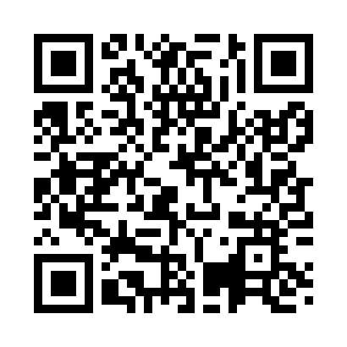

**Prayer times for Saaremoisa, Estonia**

**Wed 1 Jan 2025 - Fri 31 Jan 2025**

**High Latitude Method: Angle Based Rule**

**Prayer Calculation Method: Muslim World League**

**Asar Calculation Method: Hanafi**

|  |  |  |  |  |  |  |  |
| --- | --- | --- | --- | --- | --- | --- | --- |
| **Date** | **Day** | **Fajr** | **Sunrise** | **Dhuhr** | **Asr** | **Maghrib** | **Isha** |
| 1 | Wed | 6:37 | 9:15 | 12:24 | 1:46 | 3:34 | 6:04 |
| 2 | Thu | 6:37 | 9:14 | 12:25 | 1:47 | 3:35 | 6:05 |
| 3 | Fri | 6:36 | 9:14 | 12:25 | 1:48 | 3:37 | 6:06 |
| 4 | Sat | 6:36 | 9:13 | 12:25 | 1:50 | 3:38 | 6:07 |
| 5 | Sun | 6:36 | 9:12 | 12:26 | 1:51 | 3:40 | 6:08 |
| 6 | Mon | 6:35 | 9:12 | 12:26 | 1:53 | 3:42 | 6:10 |
| 7 | Tue | 6:35 | 9:11 | 12:27 | 1:54 | 3:44 | 6:11 |
| 8 | Wed | 6:35 | 9:10 | 12:27 | 1:56 | 3:45 | 6:12 |
| 9 | Thu | 6:34 | 9:09 | 12:28 | 1:57 | 3:47 | 6:14 |
| 10 | Fri | 6:33 | 9:08 | 12:28 | 1:59 | 3:49 | 6:15 |
| 11 | Sat | 6:33 | 9:07 | 12:28 | 2:01 | 3:51 | 6:17 |
| 12 | Sun | 6:32 | 9:05 | 12:29 | 2:03 | 3:53 | 6:18 |
| 13 | Mon | 6:31 | 9:04 | 12:29 | 2:04 | 3:55 | 6:20 |
| 14 | Tue | 6:31 | 9:03 | 12:30 | 2:06 | 3:57 | 6:21 |
| 15 | Wed | 6:30 | 9:01 | 12:30 | 2:08 | 3:59 | 6:23 |
| 16 | Thu | 6:29 | 9:00 | 12:30 | 2:10 | 4:02 | 6:24 |
| 17 | Fri | 6:28 | 8:58 | 12:31 | 2:12 | 4:04 | 6:26 |
| 18 | Sat | 6:27 | 8:57 | 12:31 | 2:14 | 4:06 | 6:28 |
| 19 | Sun | 6:26 | 8:55 | 12:31 | 2:16 | 4:08 | 6:30 |
| 20 | Mon | 6:25 | 8:53 | 12:32 | 2:18 | 4:11 | 6:31 |
| 21 | Tue | 6:23 | 8:52 | 12:32 | 2:20 | 4:13 | 6:33 |
| 22 | Wed | 6:22 | 8:50 | 12:32 | 2:22 | 4:15 | 6:35 |
| 23 | Thu | 6:21 | 8:48 | 12:32 | 2:24 | 4:18 | 6:37 |
| 24 | Fri | 6:20 | 8:46 | 12:33 | 2:27 | 4:20 | 6:39 |
| 25 | Sat | 6:18 | 8:44 | 12:33 | 2:29 | 4:23 | 6:40 |
| 26 | Sun | 6:17 | 8:42 | 12:33 | 2:31 | 4:25 | 6:42 |
| 27 | Mon | 6:15 | 8:40 | 12:33 | 2:33 | 4:27 | 6:44 |
| 28 | Tue | 6:14 | 8:38 | 12:33 | 2:35 | 4:30 | 6:46 |
| 29 | Wed | 6:12 | 8:36 | 12:34 | 2:38 | 4:32 | 6:48 |
| 30 | Thu | 6:11 | 8:34 | 12:34 | 2:40 | 4:35 | 6:50 |
| 31 | Fri | 6:09 | 8:32 | 12:34 | 2:42 | 4:37 | 6:52 |

**Prayer times provided by https://www.salahtimes.com**