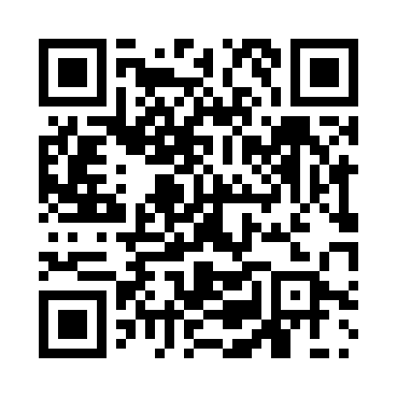

**Prayer times for Slonim, Belarus**

**Sun 1 Dec 2024 - Tue 31 Dec 2024**

**High Latitude Method: Angle Based Rule**

**Prayer Calculation Method: Muslim World League**

**Asar Calculation Method: Shafi**

|  |  |  |  |  |  |  |  |
| --- | --- | --- | --- | --- | --- | --- | --- |
| **Date** | **Day** | **Fajr** | **Sunrise** | **Dhuhr** | **Asr** | **Maghrib** | **Isha** |
| 1 | Sun | 7:03 | 9:10 | 1:08 | 2:48 | 5:05 | 7:05 |
| 2 | Mon | 7:04 | 9:11 | 1:08 | 2:47 | 5:05 | 7:05 |
| 3 | Tue | 7:05 | 9:13 | 1:09 | 2:47 | 5:04 | 7:05 |
| 4 | Wed | 7:07 | 9:14 | 1:09 | 2:47 | 5:04 | 7:04 |
| 5 | Thu | 7:08 | 9:16 | 1:10 | 2:46 | 5:03 | 7:04 |
| 6 | Fri | 7:09 | 9:17 | 1:10 | 2:46 | 5:03 | 7:04 |
| 7 | Sat | 7:10 | 9:18 | 1:10 | 2:46 | 5:02 | 7:04 |
| 8 | Sun | 7:11 | 9:19 | 1:11 | 2:46 | 5:02 | 7:04 |
| 9 | Mon | 7:12 | 9:20 | 1:11 | 2:46 | 5:02 | 7:04 |
| 10 | Tue | 7:13 | 9:22 | 1:12 | 2:46 | 5:02 | 7:04 |
| 11 | Wed | 7:14 | 9:23 | 1:12 | 2:46 | 5:01 | 7:04 |
| 12 | Thu | 7:14 | 9:24 | 1:13 | 2:46 | 5:01 | 7:04 |
| 13 | Fri | 7:15 | 9:25 | 1:13 | 2:46 | 5:01 | 7:04 |
| 14 | Sat | 7:16 | 9:26 | 1:14 | 2:46 | 5:01 | 7:04 |
| 15 | Sun | 7:17 | 9:26 | 1:14 | 2:46 | 5:01 | 7:04 |
| 16 | Mon | 7:18 | 9:27 | 1:15 | 2:47 | 5:02 | 7:04 |
| 17 | Tue | 7:18 | 9:28 | 1:15 | 2:47 | 5:02 | 7:05 |
| 18 | Wed | 7:19 | 9:29 | 1:16 | 2:47 | 5:02 | 7:05 |
| 19 | Thu | 7:19 | 9:29 | 1:16 | 2:48 | 5:03 | 7:06 |
| 20 | Fri | 7:20 | 9:30 | 1:17 | 2:48 | 5:03 | 7:06 |
| 21 | Sat | 7:21 | 9:31 | 1:17 | 2:48 | 5:03 | 7:06 |
| 22 | Sun | 7:21 | 9:31 | 1:18 | 2:49 | 5:04 | 7:07 |
| 23 | Mon | 7:22 | 9:31 | 1:18 | 2:50 | 5:05 | 7:08 |
| 24 | Tue | 7:22 | 9:32 | 1:18 | 2:50 | 5:05 | 7:08 |
| 25 | Wed | 7:22 | 9:32 | 1:19 | 2:51 | 5:06 | 7:09 |
| 26 | Thu | 7:23 | 9:32 | 1:19 | 2:52 | 5:07 | 7:10 |
| 27 | Fri | 7:23 | 9:33 | 1:20 | 2:52 | 5:08 | 7:10 |
| 28 | Sat | 7:23 | 9:33 | 1:20 | 2:53 | 5:09 | 7:11 |
| 29 | Sun | 7:23 | 9:33 | 1:21 | 2:54 | 5:09 | 7:12 |
| 30 | Mon | 7:23 | 9:33 | 1:21 | 2:55 | 5:10 | 7:13 |
| 31 | Tue | 7:24 | 9:33 | 1:22 | 2:56 | 5:11 | 7:14 |

**Prayer times provided by https://www.salahtimes.com**