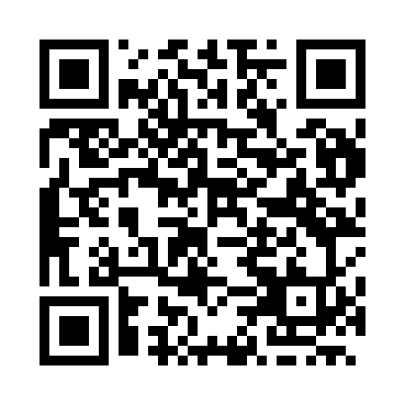

**Prayer times for Moscow, Russia**

**Fri 1 Nov 2024 - Sat 30 Nov 2024**

**High Latitude Method: Angle Based Rule**

**Prayer Calculation Method: Spiritual Administration of Muslims of Russia**

**Asar Calculation Method: Shafi**

|  |  |  |  |  |  |  |  |
| --- | --- | --- | --- | --- | --- | --- | --- |
| **Date** | **Day** | **Fajr** | **Sunrise** | **Dhuhr** | **Asr** | **Maghrib** | **Isha** |
| 1 | Fri | 5:44 | 7:36 | 12:13 | 2:20 | 4:49 | 6:34 |
| 2 | Sat | 5:46 | 7:38 | 12:13 | 2:18 | 4:47 | 6:32 |
| 3 | Sun | 5:48 | 7:40 | 12:13 | 2:17 | 4:45 | 6:30 |
| 4 | Mon | 5:50 | 7:43 | 12:13 | 2:15 | 4:43 | 6:28 |
| 5 | Tue | 5:52 | 7:45 | 12:13 | 2:14 | 4:41 | 6:27 |
| 6 | Wed | 5:53 | 7:47 | 12:13 | 2:12 | 4:39 | 6:25 |
| 7 | Thu | 5:55 | 7:49 | 12:13 | 2:11 | 4:37 | 6:23 |
| 8 | Fri | 5:57 | 7:51 | 12:13 | 2:09 | 4:35 | 6:22 |
| 9 | Sat | 5:59 | 7:53 | 12:13 | 2:08 | 4:33 | 6:20 |
| 10 | Sun | 6:00 | 7:55 | 12:13 | 2:06 | 4:31 | 6:19 |
| 11 | Mon | 6:02 | 7:57 | 12:14 | 2:05 | 4:29 | 6:17 |
| 12 | Tue | 6:04 | 7:59 | 12:14 | 2:04 | 4:27 | 6:16 |
| 13 | Wed | 6:05 | 8:01 | 12:14 | 2:02 | 4:25 | 6:14 |
| 14 | Thu | 6:07 | 8:03 | 12:14 | 2:01 | 4:24 | 6:13 |
| 15 | Fri | 6:09 | 8:05 | 12:14 | 2:00 | 4:22 | 6:12 |
| 16 | Sat | 6:10 | 8:07 | 12:14 | 1:59 | 4:20 | 6:10 |
| 17 | Sun | 6:12 | 8:09 | 12:15 | 1:57 | 4:19 | 6:09 |
| 18 | Mon | 6:14 | 8:11 | 12:15 | 1:56 | 4:17 | 6:08 |
| 19 | Tue | 6:15 | 8:13 | 12:15 | 1:55 | 4:16 | 6:07 |
| 20 | Wed | 6:17 | 8:15 | 12:15 | 1:54 | 4:14 | 6:06 |
| 21 | Thu | 6:18 | 8:17 | 12:15 | 1:53 | 4:13 | 6:05 |
| 22 | Fri | 6:20 | 8:19 | 12:16 | 1:52 | 4:11 | 6:04 |
| 23 | Sat | 6:21 | 8:21 | 12:16 | 1:51 | 4:10 | 6:03 |
| 24 | Sun | 6:23 | 8:23 | 12:16 | 1:50 | 4:09 | 6:02 |
| 25 | Mon | 6:24 | 8:25 | 12:17 | 1:50 | 4:08 | 6:01 |
| 26 | Tue | 6:26 | 8:27 | 12:17 | 1:49 | 4:07 | 6:00 |
| 27 | Wed | 6:27 | 8:28 | 12:17 | 1:48 | 4:05 | 5:59 |
| 28 | Thu | 6:29 | 8:30 | 12:18 | 1:47 | 4:04 | 5:59 |
| 29 | Fri | 6:30 | 8:32 | 12:18 | 1:47 | 4:03 | 5:58 |
| 30 | Sat | 6:31 | 8:34 | 12:18 | 1:46 | 4:02 | 5:57 |

**Prayer times provided by https://www.salahtimes.com**