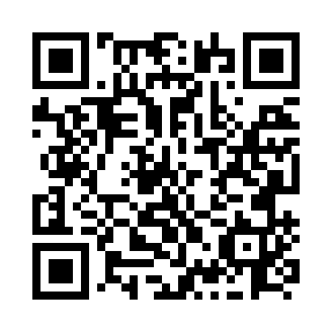
Prayer times for De Grasse, Quebec, Canada
Wed 1 May 2024 - Fri 31 May 2024
High Latitude Method: Angle Based Rule
Prayer Calculation Method: Islamic Society of North America
Asar Calculation Method: Hanafi

Date | Day | Fajr | Sunrise | Dhuhr | Asr | Maghrib | Isha
1 | Wed | 3:08 | 4:59 | 12:22 | 5:28 | 7:45 | 9:37
2 | Thu | 3:06 | 4:58 | 12:22 | 5:29 | 7:47 | 9:39
3 | Fri | 3:03 | 4:56 | 12:22 | 5:30 | 7:48 | 9:42
4 | Sat | 3:01 | 4:54 | 12:22 | 5:31 | 7:50 | 9:44
5 | Sun | 2:58 | 4:53 | 12:22 | 5:32 | 7:51 | 9:47
6 | Mon | 2:55 | 4:51 | 12:21 | 5:33 | 7:53 | 9:49
7 | Tue | 2:53 | 4:49 | 12:21 | 5:33 | 7:54 | 9:52
8 | Wed | 2:50 | 4:48 | 12:21 | 5:34 | 7:56 | 9:54
9 | Thu | 2:47 | 4:46 | 12:21 | 5:35 | 7:57 | 9:57
10 | Fri | 2:45 | 4:45 | 12:21 | 5:36 | 7:59 | 9:59
11 | Sat | 2:42 | 4:43 | 12:21 | 5:37 | 8:00 | 10:02
12 | Sun | 2:40 | 4:42 | 12:21 | 5:38 | 8:02 | 10:04
13 | Mon | 2:37 | 4:40 | 12:21 | 5:39 | 8:03 | 10:07
14 | Tue | 2:34 | 4:39 | 12:21 | 5:40 | 8:05 | 10:09
15 | Wed | 2:32 | 4:37 | 12:21 | 5:40 | 8:06 | 10:12
16 | Thu | 2:29 | 4:36 | 12:21 | 5:41 | 8:07 | 10:14
17 | Fri | 2:28 | 4:35 | 12:21 | 5:42 | 8:09 | 10:15
18 | Sat | 2:27 | 4:33 | 12:21 | 5:43 | 8:10 | 10:16
19 | Sun | 2:27 | 4:32 | 12:21 | 5:44 | 8:11 | 10:17
20 | Mon | 2:26 | 4:31 | 12:21 | 5:44 | 8:13 | 10:17
21 | Tue | 2:26 | 4:30 | 12:22 | 5:45 | 8:14 | 10:18
22 | Wed | 2:25 | 4:28 | 12:22 | 5:46 | 8:15 | 10:19
23 | Thu | 2:25 | 4:27 | 12:22 | 5:47 | 8:17 | 10:19
24 | Fri | 2:24 | 4:26 | 12:22 | 5:48 | 8:18 | 10:20
25 | Sat | 2:24 | 4:25 | 12:22 | 5:48 | 8:19 | 10:21
26 | Sun | 2:23 | 4:24 | 12:22 | 5:49 | 8:20 | 10:21
27 | Mon | 2:23 | 4:23 | 12:22 | 5:50 | 8:21 | 10:22
28 | Tue | 2:22 | 4:22 | 12:22 | 5:50 | 8:23 | 10:23
29 | Wed | 2:22 | 4:22 | 12:22 | 5:51 | 8:24 | 10:23
30 | Thu | 2:22 | 4:21 | 12:23 | 5:52 | 8:25 | 10:24
31 | Fri | 2:21 | 4:20 | 12:23 | 5:52 | 8:26 | 10:24
Prayer times provided by https://www.salahtimes.com

