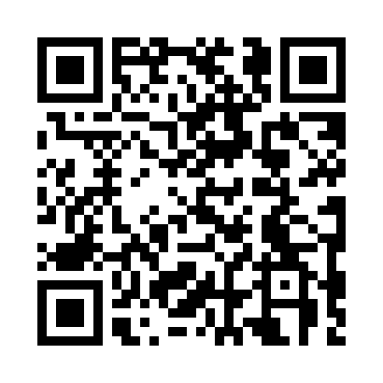

**Prayer times for Marsh Lake, Yukon, Canada**

**Sun 1 Dec 2024 - Tue 31 Dec 2024**

**High Latitude Method: Angle Based Rule**

**Prayer Calculation Method: Islamic Society of North America**

**Asar Calculation Method: Hanafi**

|  |  |  |  |  |  |  |  |
| --- | --- | --- | --- | --- | --- | --- | --- |
| **Date** | **Day** | **Fajr** | **Sunrise** | **Dhuhr** | **Asr** | **Maghrib** | **Isha** |
| 1 | Sun | 7:20 | 9:38 | 12:47 | 2:06 | 3:54 | 6:13 |
| 2 | Mon | 7:21 | 9:40 | 12:47 | 2:05 | 3:53 | 6:12 |
| 3 | Tue | 7:23 | 9:42 | 12:47 | 2:04 | 3:52 | 6:12 |
| 4 | Wed | 7:24 | 9:44 | 12:48 | 2:03 | 3:51 | 6:11 |
| 5 | Thu | 7:26 | 9:46 | 12:48 | 2:03 | 3:50 | 6:11 |
| 6 | Fri | 7:27 | 9:48 | 12:49 | 2:02 | 3:49 | 6:10 |
| 7 | Sat | 7:28 | 9:49 | 12:49 | 2:01 | 3:48 | 6:10 |
| 8 | Sun | 7:29 | 9:51 | 12:50 | 2:01 | 3:48 | 6:09 |
| 9 | Mon | 7:30 | 9:52 | 12:50 | 2:00 | 3:47 | 6:09 |
| 10 | Tue | 7:32 | 9:54 | 12:50 | 2:00 | 3:47 | 6:09 |
| 11 | Wed | 7:33 | 9:55 | 12:51 | 2:00 | 3:46 | 6:09 |
| 12 | Thu | 7:34 | 9:57 | 12:51 | 2:00 | 3:46 | 6:09 |
| 13 | Fri | 7:35 | 9:58 | 12:52 | 1:59 | 3:46 | 6:09 |
| 14 | Sat | 7:36 | 9:59 | 12:52 | 1:59 | 3:45 | 6:09 |
| 15 | Sun | 7:36 | 10:00 | 12:53 | 1:59 | 3:45 | 6:09 |
| 16 | Mon | 7:37 | 10:01 | 12:53 | 2:00 | 3:45 | 6:09 |
| 17 | Tue | 7:38 | 10:02 | 12:54 | 2:00 | 3:45 | 6:10 |
| 18 | Wed | 7:39 | 10:03 | 12:54 | 2:00 | 3:46 | 6:10 |
| 19 | Thu | 7:39 | 10:04 | 12:55 | 2:00 | 3:46 | 6:10 |
| 20 | Fri | 7:40 | 10:04 | 12:55 | 2:01 | 3:46 | 6:11 |
| 21 | Sat | 7:40 | 10:05 | 12:56 | 2:01 | 3:47 | 6:11 |
| 22 | Sun | 7:41 | 10:05 | 12:56 | 2:02 | 3:48 | 6:12 |
| 23 | Mon | 7:41 | 10:05 | 12:57 | 2:03 | 3:48 | 6:13 |
| 24 | Tue | 7:41 | 10:06 | 12:57 | 2:03 | 3:49 | 6:13 |
| 25 | Wed | 7:42 | 10:06 | 12:58 | 2:04 | 3:50 | 6:14 |
| 26 | Thu | 7:42 | 10:06 | 12:58 | 2:05 | 3:51 | 6:15 |
| 27 | Fri | 7:42 | 10:06 | 12:59 | 2:06 | 3:52 | 6:16 |
| 28 | Sat | 7:42 | 10:06 | 12:59 | 2:07 | 3:53 | 6:17 |
| 29 | Sun | 7:42 | 10:05 | 1:00 | 2:08 | 3:54 | 6:18 |
| 30 | Mon | 7:42 | 10:05 | 1:00 | 2:09 | 3:56 | 6:19 |
| 31 | Tue | 7:42 | 10:05 | 1:01 | 2:10 | 3:57 | 6:20 |

**Prayer times provided by https://www.salahtimes.com**