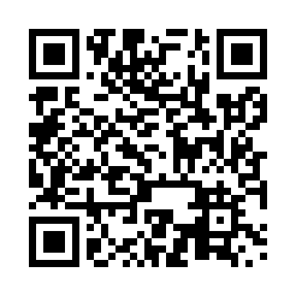
Prayer times for Blagousse, Quebec, Canada
Mon 1 Apr 2024 - Tue 30 Apr 2024
High Latitude Method: Angle Based Rule
Prayer Calculation Method: Islamic Society of North America
Asar Calculation Method: Hanafi

Date | Day | Fajr | Sunrise | Dhuhr | Asr | Maghrib | Isha
1 | Mon | 4:52 | 6:19 | 12:45 | 5:14 | 7:12 | 8:40
2 | Tue | 4:49 | 6:17 | 12:45 | 5:15 | 7:13 | 8:42
3 | Wed | 4:47 | 6:15 | 12:45 | 5:16 | 7:15 | 8:43
4 | Thu | 4:45 | 6:13 | 12:44 | 5:17 | 7:16 | 8:45
5 | Fri | 4:42 | 6:11 | 12:44 | 5:18 | 7:18 | 8:47
6 | Sat | 4:40 | 6:09 | 12:44 | 5:19 | 7:19 | 8:48
7 | Sun | 4:38 | 6:07 | 12:43 | 5:20 | 7:20 | 8:50
8 | Mon | 4:36 | 6:05 | 12:43 | 5:21 | 7:22 | 8:52
9 | Tue | 4:33 | 6:03 | 12:43 | 5:22 | 7:23 | 8:54
10 | Wed | 4:31 | 6:01 | 12:43 | 5:23 | 7:25 | 8:56
11 | Thu | 4:29 | 5:59 | 12:42 | 5:24 | 7:26 | 8:57
12 | Fri | 4:26 | 5:58 | 12:42 | 5:25 | 7:28 | 8:59
13 | Sat | 4:24 | 5:56 | 12:42 | 5:26 | 7:29 | 9:01
14 | Sun | 4:22 | 5:54 | 12:42 | 5:27 | 7:30 | 9:03
15 | Mon | 4:19 | 5:52 | 12:41 | 5:28 | 7:32 | 9:05
16 | Tue | 4:17 | 5:50 | 12:41 | 5:28 | 7:33 | 9:07
17 | Wed | 4:15 | 5:48 | 12:41 | 5:29 | 7:35 | 9:08
18 | Thu | 4:12 | 5:46 | 12:41 | 5:30 | 7:36 | 9:10
19 | Fri | 4:10 | 5:44 | 12:41 | 5:31 | 7:37 | 9:12
20 | Sat | 4:08 | 5:43 | 12:40 | 5:32 | 7:39 | 9:14
21 | Sun | 4:05 | 5:41 | 12:40 | 5:33 | 7:40 | 9:16
22 | Mon | 4:03 | 5:39 | 12:40 | 5:34 | 7:42 | 9:18
23 | Tue | 4:01 | 5:37 | 12:40 | 5:35 | 7:43 | 9:20
24 | Wed | 3:58 | 5:36 | 12:40 | 5:36 | 7:44 | 9:22
25 | Thu | 3:56 | 5:34 | 12:39 | 5:36 | 7:46 | 9:24
26 | Fri | 3:54 | 5:32 | 12:39 | 5:37 | 7:47 | 9:26
27 | Sat | 3:52 | 5:30 | 12:39 | 5:38 | 7:49 | 9:28
28 | Sun | 3:49 | 5:29 | 12:39 | 5:39 | 7:50 | 9:30
29 | Mon | 3:47 | 5:27 | 12:39 | 5:40 | 7:51 | 9:32
30 | Tue | 3:45 | 5:25 | 12:39 | 5:41 | 7:53 | 9:34
Prayer times provided by https://www.salahtimes.com

