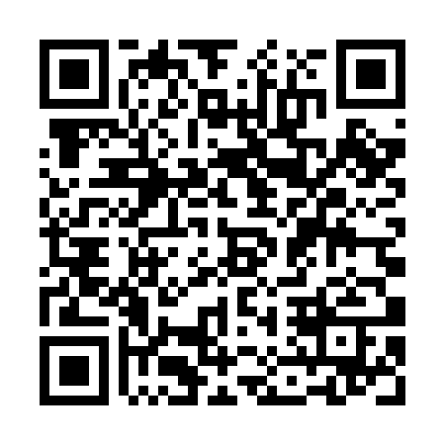

**Prayer times for Kolwezi, Democratic Republic Congo**

**Fri 1 Nov 2024 - Sat 30 Nov 2024**

**High Latitude Method: None**

**Prayer Calculation Method: Muslim World League**

**Asar Calculation Method: Shafi**

|  |  |  |  |  |  |  |  |
| --- | --- | --- | --- | --- | --- | --- | --- |
| **Date** | **Day** | **Fajr** | **Sunrise** | **Dhuhr** | **Asr** | **Maghrib** | **Isha** |
| 1 | Fri | 3:34 | 4:47 | 11:02 | 2:14 | 5:17 | 6:25 |
| 2 | Sat | 3:33 | 4:47 | 11:02 | 2:14 | 5:17 | 6:26 |
| 3 | Sun | 3:33 | 4:46 | 11:02 | 2:15 | 5:17 | 6:26 |
| 4 | Mon | 3:33 | 4:46 | 11:02 | 2:16 | 5:17 | 6:27 |
| 5 | Tue | 3:32 | 4:46 | 11:02 | 2:16 | 5:18 | 6:27 |
| 6 | Wed | 3:32 | 4:46 | 11:02 | 2:17 | 5:18 | 6:27 |
| 7 | Thu | 3:32 | 4:45 | 11:02 | 2:17 | 5:18 | 6:28 |
| 8 | Fri | 3:31 | 4:45 | 11:02 | 2:18 | 5:19 | 6:28 |
| 9 | Sat | 3:31 | 4:45 | 11:02 | 2:19 | 5:19 | 6:29 |
| 10 | Sun | 3:31 | 4:45 | 11:02 | 2:19 | 5:19 | 6:29 |
| 11 | Mon | 3:30 | 4:45 | 11:02 | 2:20 | 5:20 | 6:30 |
| 12 | Tue | 3:30 | 4:45 | 11:02 | 2:20 | 5:20 | 6:30 |
| 13 | Wed | 3:30 | 4:45 | 11:02 | 2:21 | 5:20 | 6:31 |
| 14 | Thu | 3:30 | 4:45 | 11:03 | 2:22 | 5:21 | 6:31 |
| 15 | Fri | 3:30 | 4:45 | 11:03 | 2:22 | 5:21 | 6:32 |
| 16 | Sat | 3:29 | 4:45 | 11:03 | 2:23 | 5:22 | 6:32 |
| 17 | Sun | 3:29 | 4:45 | 11:03 | 2:23 | 5:22 | 6:33 |
| 18 | Mon | 3:29 | 4:45 | 11:03 | 2:24 | 5:22 | 6:33 |
| 19 | Tue | 3:29 | 4:45 | 11:04 | 2:25 | 5:23 | 6:34 |
| 20 | Wed | 3:29 | 4:45 | 11:04 | 2:25 | 5:23 | 6:34 |
| 21 | Thu | 3:29 | 4:45 | 11:04 | 2:26 | 5:24 | 6:35 |
| 22 | Fri | 3:29 | 4:45 | 11:04 | 2:27 | 5:24 | 6:36 |
| 23 | Sat | 3:29 | 4:45 | 11:05 | 2:27 | 5:25 | 6:36 |
| 24 | Sun | 3:29 | 4:45 | 11:05 | 2:28 | 5:25 | 6:37 |
| 25 | Mon | 3:29 | 4:45 | 11:05 | 2:28 | 5:26 | 6:37 |
| 26 | Tue | 3:29 | 4:45 | 11:06 | 2:29 | 5:26 | 6:38 |
| 27 | Wed | 3:29 | 4:45 | 11:06 | 2:30 | 5:27 | 6:39 |
| 28 | Thu | 3:29 | 4:45 | 11:06 | 2:30 | 5:27 | 6:39 |
| 29 | Fri | 3:29 | 4:46 | 11:07 | 2:31 | 5:28 | 6:40 |
| 30 | Sat | 3:29 | 4:46 | 11:07 | 2:31 | 5:28 | 6:40 |

**Prayer times provided by https://www.salahtimes.com**