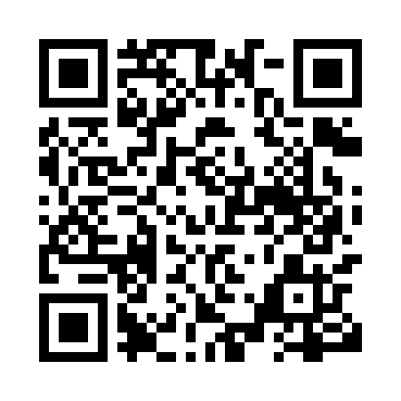
Prayer times for Biscotasing, Ontario, Canada
Wed 1 May 2024 - Fri 31 May 2024
High Latitude Method: Angle Based Rule
Prayer Calculation Method: Islamic Society of North America
Asar Calculation Method: Hanafi

Date | Day | Fajr | Sunrise | Dhuhr | Asr | Maghrib | Isha
1 | Wed | 4:30 | 6:11 | 1:25 | 6:28 | 8:41 | 10:22
2 | Thu | 4:28 | 6:10 | 1:25 | 6:29 | 8:42 | 10:24
3 | Fri | 4:26 | 6:08 | 1:25 | 6:30 | 8:43 | 10:26
4 | Sat | 4:24 | 6:06 | 1:25 | 6:31 | 8:45 | 10:28
5 | Sun | 4:22 | 6:05 | 1:25 | 6:32 | 8:46 | 10:30
6 | Mon | 4:19 | 6:03 | 1:25 | 6:32 | 8:47 | 10:32
7 | Tue | 4:17 | 6:02 | 1:25 | 6:33 | 8:49 | 10:34
8 | Wed | 4:15 | 6:01 | 1:25 | 6:34 | 8:50 | 10:36
9 | Thu | 4:13 | 5:59 | 1:25 | 6:35 | 8:51 | 10:38
10 | Fri | 4:11 | 5:58 | 1:25 | 6:36 | 8:53 | 10:40
11 | Sat | 4:09 | 5:56 | 1:25 | 6:36 | 8:54 | 10:42
12 | Sun | 4:07 | 5:55 | 1:25 | 6:37 | 8:55 | 10:44
13 | Mon | 4:05 | 5:54 | 1:25 | 6:38 | 8:56 | 10:46
14 | Tue | 4:03 | 5:53 | 1:25 | 6:39 | 8:58 | 10:48
15 | Wed | 4:01 | 5:51 | 1:25 | 6:39 | 8:59 | 10:50
16 | Thu | 3:59 | 5:50 | 1:25 | 6:40 | 9:00 | 10:52
17 | Fri | 3:57 | 5:49 | 1:25 | 6:41 | 9:01 | 10:54
18 | Sat | 3:55 | 5:48 | 1:25 | 6:42 | 9:03 | 10:56
19 | Sun | 3:53 | 5:47 | 1:25 | 6:42 | 9:04 | 10:58
20 | Mon | 3:51 | 5:46 | 1:25 | 6:43 | 9:05 | 11:00
21 | Tue | 3:49 | 5:45 | 1:25 | 6:44 | 9:06 | 11:02
22 | Wed | 3:48 | 5:44 | 1:25 | 6:44 | 9:07 | 11:04
23 | Thu | 3:46 | 5:43 | 1:25 | 6:45 | 9:08 | 11:06
24 | Fri | 3:44 | 5:42 | 1:25 | 6:46 | 9:09 | 11:08
25 | Sat | 3:42 | 5:41 | 1:25 | 6:46 | 9:11 | 11:09
26 | Sun | 3:41 | 5:40 | 1:26 | 6:47 | 9:12 | 11:11
27 | Mon | 3:39 | 5:39 | 1:26 | 6:48 | 9:13 | 11:13
28 | Tue | 3:38 | 5:38 | 1:26 | 6:48 | 9:14 | 11:15
29 | Wed | 3:36 | 5:38 | 1:26 | 6:49 | 9:15 | 11:17
30 | Thu | 3:35 | 5:37 | 1:26 | 6:49 | 9:16 | 11:18
31 | Fri | 3:33 | 5:36 | 1:26 | 6:50 | 9:17 | 11:20
Prayer times provided by https://www.salahtimes.com

