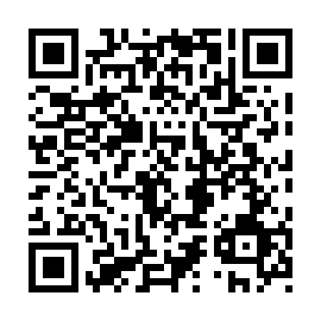
Prayer times for Tupirvikallak, Quebec, Canada
Mon 1 Apr 2024 - Tue 30 Apr 2024
High Latitude Method: Angle Based Rule
Prayer Calculation Method: Islamic Society of North America
Asar Calculation Method: Hanafi

Date | Day | Fajr | Sunrise | Dhuhr | Asr | Maghrib | Isha
1 | Mon | 3:53 | 6:08 | 12:51 | 5:12 | 7:35 | 9:50
2 | Tue | 3:48 | 6:04 | 12:50 | 5:14 | 7:37 | 9:54
3 | Wed | 3:44 | 6:01 | 12:50 | 5:16 | 7:40 | 9:58
4 | Thu | 3:39 | 5:58 | 12:50 | 5:18 | 7:43 | 10:02
5 | Fri | 3:35 | 5:55 | 12:49 | 5:20 | 7:45 | 10:07
6 | Sat | 3:30 | 5:52 | 12:49 | 5:21 | 7:48 | 10:11
7 | Sun | 3:25 | 5:48 | 12:49 | 5:23 | 7:51 | 10:15
8 | Mon | 3:20 | 5:45 | 12:49 | 5:25 | 7:53 | 10:20
9 | Tue | 3:16 | 5:42 | 12:48 | 5:27 | 7:56 | 10:22
10 | Wed | 3:14 | 5:39 | 12:48 | 5:29 | 7:59 | 10:24
11 | Thu | 3:12 | 5:36 | 12:48 | 5:31 | 8:01 | 10:25
12 | Fri | 3:10 | 5:33 | 12:47 | 5:32 | 8:04 | 10:26
13 | Sat | 3:09 | 5:29 | 12:47 | 5:34 | 8:07 | 10:27
14 | Sun | 3:07 | 5:26 | 12:47 | 5:36 | 8:09 | 10:28
15 | Mon | 3:05 | 5:23 | 12:47 | 5:38 | 8:12 | 10:30
16 | Tue | 3:04 | 5:20 | 12:47 | 5:39 | 8:15 | 10:31
17 | Wed | 3:02 | 5:17 | 12:46 | 5:41 | 8:17 | 10:32
18 | Thu | 3:00 | 5:14 | 12:46 | 5:43 | 8:20 | 10:33
19 | Fri | 2:59 | 5:11 | 12:46 | 5:45 | 8:23 | 10:35
20 | Sat | 2:57 | 5:07 | 12:46 | 5:46 | 8:25 | 10:36
21 | Sun | 2:55 | 5:04 | 12:45 | 5:48 | 8:28 | 10:37
22 | Mon | 2:54 | 5:01 | 12:45 | 5:50 | 8:31 | 10:38
23 | Tue | 2:52 | 4:58 | 12:45 | 5:51 | 8:33 | 10:40
24 | Wed | 2:50 | 4:55 | 12:45 | 5:53 | 8:36 | 10:41
25 | Thu | 2:49 | 4:52 | 12:45 | 5:55 | 8:39 | 10:42
26 | Fri | 2:47 | 4:49 | 12:45 | 5:56 | 8:41 | 10:43
27 | Sat | 2:46 | 4:46 | 12:44 | 5:58 | 8:44 | 10:45
28 | Sun | 2:44 | 4:43 | 12:44 | 5:59 | 8:47 | 10:46
29 | Mon | 2:42 | 4:40 | 12:44 | 6:01 | 8:50 | 10:47
30 | Tue | 2:41 | 4:37 | 12:44 | 6:03 | 8:52 | 10:49
Prayer times provided by https://www.salahtimes.com

