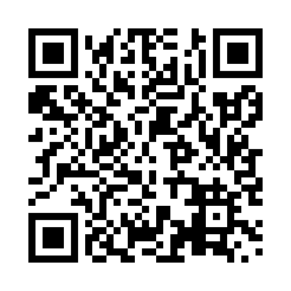
Prayer times for Iqiattavik, Quebec, Canada
Mon 1 Jul 2024 - Wed 31 Jul 2024
High Latitude Method: Angle Based Rule
Prayer Calculation Method: Islamic Society of North America
Asar Calculation Method: Hanafi

Date | Day | Fajr | Sunrise | Dhuhr | Asr | Maghrib | Isha
1 | Mon | 2:18 | 3:27 | 1:10 | 7:14 | 10:52 | 12:00
2 | Tue | 2:19 | 3:28 | 1:10 | 7:14 | 10:51 | 12:00
3 | Wed | 2:20 | 3:30 | 1:10 | 7:13 | 10:49 | 11:59
4 | Thu | 2:21 | 3:31 | 1:10 | 7:13 | 10:48 | 11:59
5 | Fri | 2:21 | 3:33 | 1:10 | 7:13 | 10:47 | 11:58
6 | Sat | 2:22 | 3:35 | 1:10 | 7:12 | 10:45 | 11:58
7 | Sun | 2:23 | 3:36 | 1:11 | 7:12 | 10:44 | 11:57
8 | Mon | 2:24 | 3:38 | 1:11 | 7:11 | 10:42 | 11:56
9 | Tue | 2:25 | 3:40 | 1:11 | 7:11 | 10:41 | 11:56
10 | Wed | 2:26 | 3:42 | 1:11 | 7:10 | 10:39 | 11:55
11 | Thu | 2:27 | 3:44 | 1:11 | 7:09 | 10:37 | 11:54
12 | Fri | 2:29 | 3:46 | 1:11 | 7:09 | 10:35 | 11:53
13 | Sat | 2:30 | 3:48 | 1:11 | 7:08 | 10:33 | 11:52
14 | Sun | 2:31 | 3:51 | 1:12 | 7:07 | 10:31 | 11:51
15 | Mon | 2:32 | 3:53 | 1:12 | 7:06 | 10:29 | 11:50
16 | Tue | 2:33 | 3:55 | 1:12 | 7:05 | 10:27 | 11:49
17 | Wed | 2:34 | 3:57 | 1:12 | 7:04 | 10:25 | 11:48
18 | Thu | 2:36 | 4:00 | 1:12 | 7:04 | 10:23 | 11:47
19 | Fri | 2:37 | 4:02 | 1:12 | 7:03 | 10:20 | 11:46
20 | Sat | 2:38 | 4:05 | 1:12 | 7:01 | 10:18 | 11:45
21 | Sun | 2:39 | 4:07 | 1:12 | 7:00 | 10:16 | 11:44
22 | Mon | 2:41 | 4:10 | 1:12 | 6:59 | 10:13 | 11:42
23 | Tue | 2:42 | 4:12 | 1:12 | 6:58 | 10:11 | 11:41
24 | Wed | 2:43 | 4:15 | 1:12 | 6:57 | 10:08 | 11:40
25 | Thu | 2:44 | 4:17 | 1:12 | 6:56 | 10:06 | 11:39
26 | Fri | 2:46 | 4:20 | 1:12 | 6:54 | 10:03 | 11:37
27 | Sat | 2:47 | 4:22 | 1:12 | 6:53 | 10:00 | 11:36
28 | Sun | 2:48 | 4:25 | 1:12 | 6:52 | 9:58 | 11:35
29 | Mon | 2:49 | 4:28 | 1:12 | 6:50 | 9:55 | 11:33
30 | Tue | 2:51 | 4:30 | 1:12 | 6:49 | 9:52 | 11:32
31 | Wed | 2:52 | 4:33 | 1:12 | 6:47 | 9:50 | 11:30
Prayer times provided by https://www.salahtimes.com

