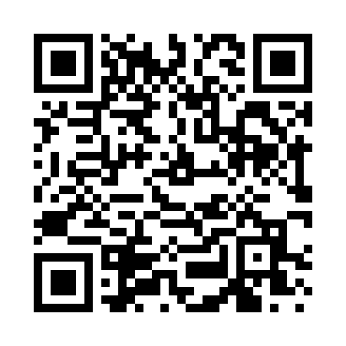
Prayer times for North Clymer, New York, USA
Mon 1 Jul 2024 - Wed 31 Jul 2024
High Latitude Method: Angle Based Rule
Prayer Calculation Method: Islamic Society of North America
Asar Calculation Method: Shafi

Date | Day | Fajr | Sunrise | Dhuhr | Asr | Maghrib | Isha
1 | Mon | 4:03 | 5:47 | 1:22 | 5:25 | 8:58 | 10:41
2 | Tue | 4:04 | 5:47 | 1:23 | 5:25 | 8:58 | 10:41
3 | Wed | 4:05 | 5:48 | 1:23 | 5:25 | 8:57 | 10:40
4 | Thu | 4:06 | 5:48 | 1:23 | 5:25 | 8:57 | 10:40
5 | Fri | 4:07 | 5:49 | 1:23 | 5:25 | 8:57 | 10:39
6 | Sat | 4:08 | 5:50 | 1:23 | 5:25 | 8:57 | 10:38
7 | Sun | 4:08 | 5:50 | 1:23 | 5:26 | 8:56 | 10:38
8 | Mon | 4:09 | 5:51 | 1:24 | 5:26 | 8:56 | 10:37
9 | Tue | 4:11 | 5:52 | 1:24 | 5:26 | 8:55 | 10:36
10 | Wed | 4:12 | 5:52 | 1:24 | 5:26 | 8:55 | 10:36
11 | Thu | 4:13 | 5:53 | 1:24 | 5:26 | 8:54 | 10:35
12 | Fri | 4:14 | 5:54 | 1:24 | 5:25 | 8:54 | 10:34
13 | Sat | 4:15 | 5:55 | 1:24 | 5:25 | 8:53 | 10:33
14 | Sun | 4:16 | 5:55 | 1:24 | 5:25 | 8:53 | 10:32
15 | Mon | 4:17 | 5:56 | 1:24 | 5:25 | 8:52 | 10:31
16 | Tue | 4:19 | 5:57 | 1:24 | 5:25 | 8:51 | 10:30
17 | Wed | 4:20 | 5:58 | 1:25 | 5:25 | 8:51 | 10:29
18 | Thu | 4:21 | 5:59 | 1:25 | 5:25 | 8:50 | 10:27
19 | Fri | 4:22 | 6:00 | 1:25 | 5:25 | 8:49 | 10:26
20 | Sat | 4:24 | 6:01 | 1:25 | 5:25 | 8:48 | 10:25
21 | Sun | 4:25 | 6:02 | 1:25 | 5:24 | 8:48 | 10:24
22 | Mon | 4:26 | 6:02 | 1:25 | 5:24 | 8:47 | 10:23
23 | Tue | 4:28 | 6:03 | 1:25 | 5:24 | 8:46 | 10:21
24 | Wed | 4:29 | 6:04 | 1:25 | 5:24 | 8:45 | 10:20
25 | Thu | 4:31 | 6:05 | 1:25 | 5:23 | 8:44 | 10:18
26 | Fri | 4:32 | 6:06 | 1:25 | 5:23 | 8:43 | 10:17
27 | Sat | 4:33 | 6:07 | 1:25 | 5:23 | 8:42 | 10:16
28 | Sun | 4:35 | 6:08 | 1:25 | 5:23 | 8:41 | 10:14
29 | Mon | 4:36 | 6:09 | 1:25 | 5:22 | 8:40 | 10:13
30 | Tue | 4:38 | 6:10 | 1:25 | 5:22 | 8:39 | 10:11
31 | Wed | 4:39 | 6:11 | 1:25 | 5:21 | 8:38 | 10:10
Prayer times provided by https://www.salahtimes.com

