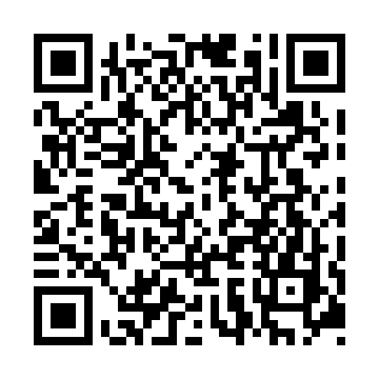

**Prayer times for Achimasahitunanuch, Quebec, Canada**

**Wed 1 Jan 2025 - Fri 31 Jan 2025**

**High Latitude Method: Angle Based Rule**

**Prayer Calculation Method: Islamic Society of North America**

**Asar Calculation Method: Hanafi**

|  |  |  |  |  |  |  |  |
| --- | --- | --- | --- | --- | --- | --- | --- |
| **Date** | **Day** | **Fajr** | **Sunrise** | **Dhuhr** | **Asr** | **Maghrib** | **Isha** |
| 1 | Wed | 6:31 | 8:28 | 12:03 | 1:49 | 3:37 | 5:35 |
| 2 | Thu | 6:30 | 8:28 | 12:03 | 1:50 | 3:39 | 5:36 |
| 3 | Fri | 6:30 | 8:27 | 12:03 | 1:51 | 3:40 | 5:37 |
| 4 | Sat | 6:30 | 8:27 | 12:04 | 1:53 | 3:41 | 5:38 |
| 5 | Sun | 6:30 | 8:27 | 12:04 | 1:54 | 3:43 | 5:39 |
| 6 | Mon | 6:30 | 8:26 | 12:05 | 1:55 | 3:44 | 5:40 |
| 7 | Tue | 6:29 | 8:25 | 12:05 | 1:57 | 3:46 | 5:42 |
| 8 | Wed | 6:29 | 8:25 | 12:06 | 1:58 | 3:47 | 5:43 |
| 9 | Thu | 6:28 | 8:24 | 12:06 | 2:00 | 3:49 | 5:44 |
| 10 | Fri | 6:28 | 8:23 | 12:06 | 2:01 | 3:50 | 5:45 |
| 11 | Sat | 6:27 | 8:22 | 12:07 | 2:03 | 3:52 | 5:47 |
| 12 | Sun | 6:27 | 8:21 | 12:07 | 2:04 | 3:54 | 5:48 |
| 13 | Mon | 6:26 | 8:20 | 12:08 | 2:06 | 3:56 | 5:50 |
| 14 | Tue | 6:25 | 8:19 | 12:08 | 2:08 | 3:57 | 5:51 |
| 15 | Wed | 6:25 | 8:18 | 12:08 | 2:09 | 3:59 | 5:52 |
| 16 | Thu | 6:24 | 8:17 | 12:09 | 2:11 | 4:01 | 5:54 |
| 17 | Fri | 6:23 | 8:16 | 12:09 | 2:13 | 4:03 | 5:56 |
| 18 | Sat | 6:22 | 8:14 | 12:09 | 2:14 | 4:05 | 5:57 |
| 19 | Sun | 6:21 | 8:13 | 12:10 | 2:16 | 4:07 | 5:59 |
| 20 | Mon | 6:20 | 8:12 | 12:10 | 2:18 | 4:09 | 6:00 |
| 21 | Tue | 6:19 | 8:10 | 12:10 | 2:20 | 4:11 | 6:02 |
| 22 | Wed | 6:18 | 8:09 | 12:10 | 2:22 | 4:13 | 6:03 |
| 23 | Thu | 6:17 | 8:07 | 12:11 | 2:24 | 4:15 | 6:05 |
| 24 | Fri | 6:16 | 8:06 | 12:11 | 2:26 | 4:17 | 6:07 |
| 25 | Sat | 6:15 | 8:04 | 12:11 | 2:28 | 4:19 | 6:08 |
| 26 | Sun | 6:13 | 8:03 | 12:11 | 2:29 | 4:21 | 6:10 |
| 27 | Mon | 6:12 | 8:01 | 12:12 | 2:31 | 4:23 | 6:12 |
| 28 | Tue | 6:11 | 7:59 | 12:12 | 2:33 | 4:25 | 6:14 |
| 29 | Wed | 6:09 | 7:57 | 12:12 | 2:35 | 4:27 | 6:15 |
| 30 | Thu | 6:08 | 7:56 | 12:12 | 2:37 | 4:30 | 6:17 |
| 31 | Fri | 6:06 | 7:54 | 12:12 | 2:39 | 4:32 | 6:19 |

**Prayer times provided by https://www.salahtimes.com**