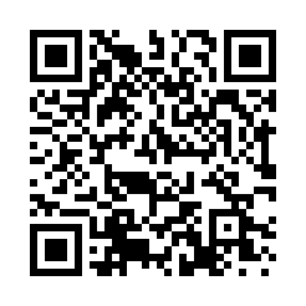
Prayer times for Soemotsa, Estonia
Wed 1 May 2024 - Fri 31 May 2024
High Latitude Method: Angle Based Rule
Prayer Calculation Method: Muslim World League
Asar Calculation Method: Hanafi

Date | Day | Fajr | Sunrise | Dhuhr | Asr | Maghrib | Isha
1 | Wed | 2:49 | 5:19 | 1:09 | 6:23 | 8:59 | 11:21
2 | Thu | 2:48 | 5:17 | 1:09 | 6:25 | 9:02 | 11:22
3 | Fri | 2:47 | 5:15 | 1:09 | 6:26 | 9:04 | 11:23
4 | Sat | 2:46 | 5:12 | 1:08 | 6:27 | 9:06 | 11:24
5 | Sun | 2:45 | 5:10 | 1:08 | 6:29 | 9:08 | 11:25
6 | Mon | 2:44 | 5:07 | 1:08 | 6:30 | 9:10 | 11:25
7 | Tue | 2:43 | 5:05 | 1:08 | 6:31 | 9:12 | 11:26
8 | Wed | 2:42 | 5:03 | 1:08 | 6:32 | 9:15 | 11:27
9 | Thu | 2:41 | 5:01 | 1:08 | 6:34 | 9:17 | 11:28
10 | Fri | 2:41 | 4:58 | 1:08 | 6:35 | 9:19 | 11:29
11 | Sat | 2:40 | 4:56 | 1:08 | 6:36 | 9:21 | 11:30
12 | Sun | 2:39 | 4:54 | 1:08 | 6:37 | 9:23 | 11:31
13 | Mon | 2:38 | 4:52 | 1:08 | 6:38 | 9:25 | 11:32
14 | Tue | 2:37 | 4:50 | 1:08 | 6:40 | 9:27 | 11:33
15 | Wed | 2:36 | 4:48 | 1:08 | 6:41 | 9:29 | 11:34
16 | Thu | 2:36 | 4:46 | 1:08 | 6:42 | 9:31 | 11:34
17 | Fri | 2:35 | 4:44 | 1:08 | 6:43 | 9:33 | 11:35
18 | Sat | 2:34 | 4:42 | 1:08 | 6:44 | 9:35 | 11:36
19 | Sun | 2:33 | 4:40 | 1:08 | 6:45 | 9:37 | 11:37
20 | Mon | 2:33 | 4:38 | 1:08 | 6:46 | 9:39 | 11:38
21 | Tue | 2:32 | 4:37 | 1:08 | 6:47 | 9:41 | 11:39
22 | Wed | 2:31 | 4:35 | 1:08 | 6:48 | 9:43 | 11:40
23 | Thu | 2:31 | 4:33 | 1:09 | 6:49 | 9:45 | 11:40
24 | Fri | 2:30 | 4:31 | 1:09 | 6:50 | 9:47 | 11:41
25 | Sat | 2:29 | 4:30 | 1:09 | 6:51 | 9:48 | 11:42
26 | Sun | 2:29 | 4:28 | 1:09 | 6:52 | 9:50 | 11:43
27 | Mon | 2:28 | 4:27 | 1:09 | 6:53 | 9:52 | 11:44
28 | Tue | 2:28 | 4:25 | 1:09 | 6:54 | 9:54 | 11:45
29 | Wed | 2:27 | 4:24 | 1:09 | 6:55 | 9:55 | 11:45
30 | Thu | 2:27 | 4:23 | 1:09 | 6:56 | 9:57 | 11:46
31 | Fri | 2:26 | 4:21 | 1:09 | 6:57 | 9:58 | 11:47
Prayer times provided by https://www.salahtimes.com

