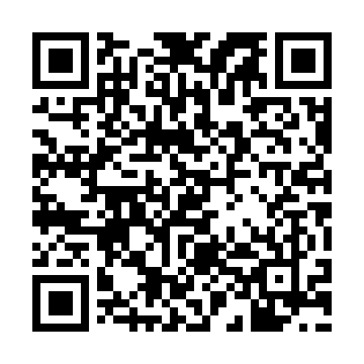

**Prayer times for Auckland, New Zealand**

**Fri 1 Nov 2024 - Sat 30 Nov 2024**

**High Latitude Method: None**

**Prayer Calculation Method: Muslim World League**

**Asar Calculation Method: Shafi**

|  |  |  |  |  |  |  |  |
| --- | --- | --- | --- | --- | --- | --- | --- |
| **Date** | **Day** | **Fajr** | **Sunrise** | **Dhuhr** | **Asr** | **Maghrib** | **Isha** |
| 1 | Fri | 4:40 | 6:16 | 1:05 | 4:50 | 7:54 | 9:24 |
| 2 | Sat | 4:38 | 6:15 | 1:05 | 4:51 | 7:55 | 9:26 |
| 3 | Sun | 4:37 | 6:14 | 1:05 | 4:51 | 7:56 | 9:27 |
| 4 | Mon | 4:35 | 6:13 | 1:05 | 4:51 | 7:57 | 9:29 |
| 5 | Tue | 4:34 | 6:12 | 1:05 | 4:52 | 7:58 | 9:30 |
| 6 | Wed | 4:33 | 6:11 | 1:05 | 4:52 | 7:59 | 9:31 |
| 7 | Thu | 4:31 | 6:10 | 1:05 | 4:52 | 8:00 | 9:33 |
| 8 | Fri | 4:30 | 6:09 | 1:05 | 4:53 | 8:01 | 9:34 |
| 9 | Sat | 4:29 | 6:08 | 1:05 | 4:53 | 8:02 | 9:36 |
| 10 | Sun | 4:27 | 6:07 | 1:05 | 4:53 | 8:03 | 9:37 |
| 11 | Mon | 4:26 | 6:06 | 1:05 | 4:53 | 8:04 | 9:38 |
| 12 | Tue | 4:25 | 6:05 | 1:05 | 4:54 | 8:06 | 9:40 |
| 13 | Wed | 4:24 | 6:05 | 1:05 | 4:54 | 8:07 | 9:41 |
| 14 | Thu | 4:22 | 6:04 | 1:05 | 4:54 | 8:08 | 9:43 |
| 15 | Fri | 4:21 | 6:03 | 1:06 | 4:55 | 8:09 | 9:44 |
| 16 | Sat | 4:20 | 6:02 | 1:06 | 4:55 | 8:10 | 9:46 |
| 17 | Sun | 4:19 | 6:02 | 1:06 | 4:56 | 8:11 | 9:47 |
| 18 | Mon | 4:18 | 6:01 | 1:06 | 4:56 | 8:12 | 9:48 |
| 19 | Tue | 4:17 | 6:00 | 1:06 | 4:56 | 8:13 | 9:50 |
| 20 | Wed | 4:16 | 6:00 | 1:07 | 4:57 | 8:14 | 9:51 |
| 21 | Thu | 4:15 | 5:59 | 1:07 | 4:57 | 8:15 | 9:53 |
| 22 | Fri | 4:14 | 5:59 | 1:07 | 4:57 | 8:16 | 9:54 |
| 23 | Sat | 4:13 | 5:58 | 1:07 | 4:58 | 8:17 | 9:56 |
| 24 | Sun | 4:12 | 5:58 | 1:08 | 4:58 | 8:18 | 9:57 |
| 25 | Mon | 4:11 | 5:57 | 1:08 | 4:59 | 8:19 | 9:58 |
| 26 | Tue | 4:11 | 5:57 | 1:08 | 4:59 | 8:20 | 10:00 |
| 27 | Wed | 4:10 | 5:57 | 1:09 | 4:59 | 8:21 | 10:01 |
| 28 | Thu | 4:09 | 5:56 | 1:09 | 5:00 | 8:22 | 10:02 |
| 29 | Fri | 4:08 | 5:56 | 1:09 | 5:00 | 8:23 | 10:04 |
| 30 | Sat | 4:08 | 5:56 | 1:10 | 5:01 | 8:24 | 10:05 |

**Prayer times provided by https://www.salahtimes.com**