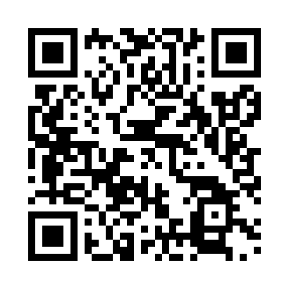

**Prayer times for Brest, Belarus**

**Fri 1 Nov 2024 - Sat 30 Nov 2024**

**High Latitude Method: Angle Based Rule**

**Prayer Calculation Method: Muslim World League**

**Asar Calculation Method: Shafi**

|  |  |  |  |  |  |  |  |
| --- | --- | --- | --- | --- | --- | --- | --- |
| **Date** | **Day** | **Fajr** | **Sunrise** | **Dhuhr** | **Asr** | **Maghrib** | **Isha** |
| 1 | Fri | 6:26 | 8:21 | 1:09 | 3:28 | 5:56 | 7:44 |
| 2 | Sat | 6:28 | 8:23 | 1:09 | 3:27 | 5:54 | 7:43 |
| 3 | Sun | 6:29 | 8:25 | 1:09 | 3:26 | 5:52 | 7:41 |
| 4 | Mon | 6:31 | 8:27 | 1:09 | 3:24 | 5:50 | 7:40 |
| 5 | Tue | 6:32 | 8:28 | 1:09 | 3:23 | 5:49 | 7:38 |
| 6 | Wed | 6:34 | 8:30 | 1:09 | 3:21 | 5:47 | 7:37 |
| 7 | Thu | 6:35 | 8:32 | 1:09 | 3:20 | 5:45 | 7:35 |
| 8 | Fri | 6:37 | 8:34 | 1:09 | 3:19 | 5:44 | 7:34 |
| 9 | Sat | 6:38 | 8:36 | 1:09 | 3:18 | 5:42 | 7:33 |
| 10 | Sun | 6:40 | 8:37 | 1:09 | 3:16 | 5:40 | 7:31 |
| 11 | Mon | 6:41 | 8:39 | 1:09 | 3:15 | 5:39 | 7:30 |
| 12 | Tue | 6:43 | 8:41 | 1:10 | 3:14 | 5:37 | 7:29 |
| 13 | Wed | 6:44 | 8:43 | 1:10 | 3:13 | 5:36 | 7:28 |
| 14 | Thu | 6:46 | 8:44 | 1:10 | 3:12 | 5:34 | 7:27 |
| 15 | Fri | 6:47 | 8:46 | 1:10 | 3:11 | 5:33 | 7:25 |
| 16 | Sat | 6:49 | 8:48 | 1:10 | 3:10 | 5:32 | 7:24 |
| 17 | Sun | 6:50 | 8:50 | 1:10 | 3:09 | 5:30 | 7:23 |
| 18 | Mon | 6:52 | 8:51 | 1:11 | 3:08 | 5:29 | 7:22 |
| 19 | Tue | 6:53 | 8:53 | 1:11 | 3:07 | 5:28 | 7:21 |
| 20 | Wed | 6:54 | 8:55 | 1:11 | 3:06 | 5:27 | 7:21 |
| 21 | Thu | 6:56 | 8:56 | 1:11 | 3:05 | 5:25 | 7:20 |
| 22 | Fri | 6:57 | 8:58 | 1:12 | 3:04 | 5:24 | 7:19 |
| 23 | Sat | 6:58 | 9:00 | 1:12 | 3:03 | 5:23 | 7:18 |
| 24 | Sun | 7:00 | 9:01 | 1:12 | 3:03 | 5:22 | 7:17 |
| 25 | Mon | 7:01 | 9:03 | 1:12 | 3:02 | 5:21 | 7:17 |
| 26 | Tue | 7:02 | 9:05 | 1:13 | 3:01 | 5:20 | 7:16 |
| 27 | Wed | 7:04 | 9:06 | 1:13 | 3:01 | 5:20 | 7:15 |
| 28 | Thu | 7:05 | 9:08 | 1:13 | 3:00 | 5:19 | 7:15 |
| 29 | Fri | 7:06 | 9:09 | 1:14 | 3:00 | 5:18 | 7:14 |
| 30 | Sat | 7:07 | 9:11 | 1:14 | 2:59 | 5:17 | 7:14 |

**Prayer times provided by https://www.salahtimes.com**