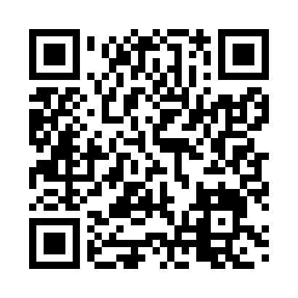

**Prayer times for Orebro, Orebro, Sweden**

**Fri 1 Nov 2024 - Sat 30 Nov 2024**

**High Latitude Method: Angle Based Rule**

**Prayer Calculation Method: Muslim World League**

**Asar Calculation Method: Hanafi**

|  |  |  |  |  |  |  |  |
| --- | --- | --- | --- | --- | --- | --- | --- |
| **Date** | **Day** | **Fajr** | **Sunrise** | **Dhuhr** | **Asr** | **Maghrib** | **Isha** |
| 1 | Fri | 4:59 | 7:19 | 11:43 | 2:09 | 4:05 | 6:17 |
| 2 | Sat | 5:02 | 7:22 | 11:43 | 2:06 | 4:03 | 6:15 |
| 3 | Sun | 5:04 | 7:24 | 11:43 | 2:04 | 4:00 | 6:13 |
| 4 | Mon | 5:06 | 7:26 | 11:43 | 2:02 | 3:58 | 6:11 |
| 5 | Tue | 5:08 | 7:29 | 11:43 | 2:00 | 3:55 | 6:09 |
| 6 | Wed | 5:10 | 7:31 | 11:43 | 1:58 | 3:53 | 6:07 |
| 7 | Thu | 5:12 | 7:34 | 11:43 | 1:56 | 3:51 | 6:05 |
| 8 | Fri | 5:14 | 7:36 | 11:43 | 1:54 | 3:48 | 6:03 |
| 9 | Sat | 5:16 | 7:39 | 11:43 | 1:51 | 3:46 | 6:01 |
| 10 | Sun | 5:18 | 7:41 | 11:43 | 1:49 | 3:44 | 6:00 |
| 11 | Mon | 5:20 | 7:44 | 11:43 | 1:47 | 3:42 | 5:58 |
| 12 | Tue | 5:22 | 7:46 | 11:43 | 1:46 | 3:39 | 5:56 |
| 13 | Wed | 5:23 | 7:49 | 11:43 | 1:44 | 3:37 | 5:55 |
| 14 | Thu | 5:25 | 7:51 | 11:44 | 1:42 | 3:35 | 5:53 |
| 15 | Fri | 5:27 | 7:53 | 11:44 | 1:40 | 3:33 | 5:52 |
| 16 | Sat | 5:29 | 7:56 | 11:44 | 1:38 | 3:31 | 5:50 |
| 17 | Sun | 5:31 | 7:58 | 11:44 | 1:36 | 3:29 | 5:49 |
| 18 | Mon | 5:33 | 8:01 | 11:44 | 1:35 | 3:27 | 5:47 |
| 19 | Tue | 5:34 | 8:03 | 11:45 | 1:33 | 3:25 | 5:46 |
| 20 | Wed | 5:36 | 8:05 | 11:45 | 1:32 | 3:23 | 5:45 |
| 21 | Thu | 5:38 | 8:08 | 11:45 | 1:30 | 3:22 | 5:44 |
| 22 | Fri | 5:40 | 8:10 | 11:45 | 1:29 | 3:20 | 5:42 |
| 23 | Sat | 5:41 | 8:12 | 11:46 | 1:27 | 3:18 | 5:41 |
| 24 | Sun | 5:43 | 8:14 | 11:46 | 1:26 | 3:17 | 5:40 |
| 25 | Mon | 5:45 | 8:16 | 11:46 | 1:24 | 3:15 | 5:39 |
| 26 | Tue | 5:46 | 8:19 | 11:47 | 1:23 | 3:14 | 5:38 |
| 27 | Wed | 5:48 | 8:21 | 11:47 | 1:22 | 3:12 | 5:37 |
| 28 | Thu | 5:49 | 8:23 | 11:47 | 1:21 | 3:11 | 5:37 |
| 29 | Fri | 5:51 | 8:25 | 11:48 | 1:20 | 3:10 | 5:36 |
| 30 | Sat | 5:52 | 8:27 | 11:48 | 1:19 | 3:08 | 5:35 |

**Prayer times provided by https://www.salahtimes.com**