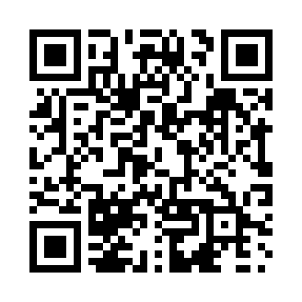
Prayer times for Ungava, Ontario, Canada
Wed 1 May 2024 - Fri 31 May 2024
High Latitude Method: Angle Based Rule
Prayer Calculation Method: Islamic Society of North America
Asar Calculation Method: Hanafi

Date | Day | Fajr | Sunrise | Dhuhr | Asr | Maghrib | Isha
1 | Wed | 4:22 | 5:55 | 1:04 | 6:04 | 8:12 | 9:47
2 | Thu | 4:20 | 5:54 | 1:03 | 6:04 | 8:14 | 9:48
3 | Fri | 4:18 | 5:53 | 1:03 | 6:05 | 8:15 | 9:50
4 | Sat | 4:16 | 5:51 | 1:03 | 6:06 | 8:16 | 9:52
5 | Sun | 4:14 | 5:50 | 1:03 | 6:07 | 8:17 | 9:54
6 | Mon | 4:12 | 5:48 | 1:03 | 6:07 | 8:18 | 9:55
7 | Tue | 4:10 | 5:47 | 1:03 | 6:08 | 8:20 | 9:57
8 | Wed | 4:08 | 5:46 | 1:03 | 6:09 | 8:21 | 9:59
9 | Thu | 4:06 | 5:44 | 1:03 | 6:09 | 8:22 | 10:01
10 | Fri | 4:05 | 5:43 | 1:03 | 6:10 | 8:23 | 10:02
11 | Sat | 4:03 | 5:42 | 1:03 | 6:11 | 8:24 | 10:04
12 | Sun | 4:01 | 5:41 | 1:03 | 6:12 | 8:26 | 10:06
13 | Mon | 3:59 | 5:40 | 1:03 | 6:12 | 8:27 | 10:07
14 | Tue | 3:58 | 5:39 | 1:03 | 6:13 | 8:28 | 10:09
15 | Wed | 3:56 | 5:37 | 1:03 | 6:14 | 8:29 | 10:11
16 | Thu | 3:54 | 5:36 | 1:03 | 6:14 | 8:30 | 10:13
17 | Fri | 3:53 | 5:35 | 1:03 | 6:15 | 8:31 | 10:14
18 | Sat | 3:51 | 5:34 | 1:03 | 6:16 | 8:32 | 10:16
19 | Sun | 3:49 | 5:33 | 1:03 | 6:16 | 8:33 | 10:18
20 | Mon | 3:48 | 5:32 | 1:03 | 6:17 | 8:34 | 10:19
21 | Tue | 3:46 | 5:31 | 1:03 | 6:17 | 8:35 | 10:21
22 | Wed | 3:45 | 5:30 | 1:03 | 6:18 | 8:37 | 10:22
23 | Thu | 3:44 | 5:30 | 1:03 | 6:19 | 8:38 | 10:24
24 | Fri | 3:42 | 5:29 | 1:03 | 6:19 | 8:39 | 10:26
25 | Sat | 3:41 | 5:28 | 1:04 | 6:20 | 8:40 | 10:27
26 | Sun | 3:39 | 5:27 | 1:04 | 6:20 | 8:40 | 10:29
27 | Mon | 3:38 | 5:27 | 1:04 | 6:21 | 8:41 | 10:30
28 | Tue | 3:37 | 5:26 | 1:04 | 6:22 | 8:42 | 10:31
29 | Wed | 3:36 | 5:25 | 1:04 | 6:22 | 8:43 | 10:33
30 | Thu | 3:35 | 5:25 | 1:04 | 6:23 | 8:44 | 10:34
31 | Fri | 3:34 | 5:24 | 1:04 | 6:23 | 8:45 | 10:36
Prayer times provided by https://www.salahtimes.com

