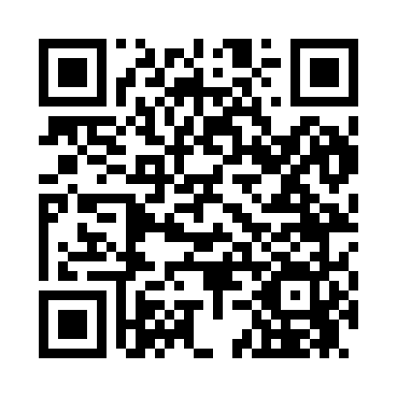
Prayer times for Cove Point, Maryland, USA
Mon 1 Apr 2024 - Tue 30 Apr 2024
High Latitude Method: Angle Based Rule
Prayer Calculation Method: Islamic Society of North America
Asar Calculation Method: Shafi

Date | Day | Fajr | Sunrise | Dhuhr | Asr | Maghrib | Isha
1 | Mon | 5:35 | 6:50 | 1:09 | 4:44 | 7:29 | 8:44
2 | Tue | 5:34 | 6:48 | 1:09 | 4:44 | 7:30 | 8:45
3 | Wed | 5:32 | 6:47 | 1:09 | 4:45 | 7:31 | 8:46
4 | Thu | 5:30 | 6:45 | 1:08 | 4:45 | 7:32 | 8:47
5 | Fri | 5:29 | 6:44 | 1:08 | 4:45 | 7:33 | 8:48
6 | Sat | 5:27 | 6:42 | 1:08 | 4:45 | 7:34 | 8:49
7 | Sun | 5:25 | 6:41 | 1:07 | 4:46 | 7:35 | 8:50
8 | Mon | 5:24 | 6:39 | 1:07 | 4:46 | 7:36 | 8:52
9 | Tue | 5:22 | 6:38 | 1:07 | 4:46 | 7:37 | 8:53
10 | Wed | 5:20 | 6:36 | 1:07 | 4:47 | 7:38 | 8:54
11 | Thu | 5:19 | 6:35 | 1:06 | 4:47 | 7:39 | 8:55
12 | Fri | 5:17 | 6:33 | 1:06 | 4:47 | 7:40 | 8:56
13 | Sat | 5:15 | 6:32 | 1:06 | 4:47 | 7:41 | 8:57
14 | Sun | 5:14 | 6:30 | 1:06 | 4:48 | 7:42 | 8:58
15 | Mon | 5:12 | 6:29 | 1:05 | 4:48 | 7:43 | 9:00
16 | Tue | 5:10 | 6:27 | 1:05 | 4:48 | 7:43 | 9:01
17 | Wed | 5:09 | 6:26 | 1:05 | 4:48 | 7:44 | 9:02
18 | Thu | 5:07 | 6:25 | 1:05 | 4:48 | 7:45 | 9:03
19 | Fri | 5:05 | 6:23 | 1:05 | 4:49 | 7:46 | 9:04
20 | Sat | 5:04 | 6:22 | 1:04 | 4:49 | 7:47 | 9:06
21 | Sun | 5:02 | 6:21 | 1:04 | 4:49 | 7:48 | 9:07
22 | Mon | 5:01 | 6:19 | 1:04 | 4:49 | 7:49 | 9:08
23 | Tue | 4:59 | 6:18 | 1:04 | 4:50 | 7:50 | 9:09
24 | Wed | 4:57 | 6:17 | 1:04 | 4:50 | 7:51 | 9:10
25 | Thu | 4:56 | 6:15 | 1:03 | 4:50 | 7:52 | 9:12
26 | Fri | 4:54 | 6:14 | 1:03 | 4:50 | 7:53 | 9:13
27 | Sat | 4:53 | 6:13 | 1:03 | 4:50 | 7:54 | 9:14
28 | Sun | 4:51 | 6:12 | 1:03 | 4:51 | 7:55 | 9:15
29 | Mon | 4:50 | 6:10 | 1:03 | 4:51 | 7:56 | 9:17
30 | Tue | 4:48 | 6:09 | 1:03 | 4:51 | 7:57 | 9:18
Prayer times provided by https://www.salahtimes.com

