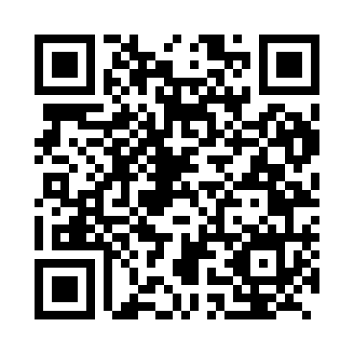

**Prayer times for Fukang, China**

**Sun 1 Dec 2024 - Tue 31 Dec 2024**

**High Latitude Method: Angle Based Rule**

**Prayer Calculation Method: Muslim World League**

**Asar Calculation Method: Shafi**

|  |  |  |  |  |  |  |  |
| --- | --- | --- | --- | --- | --- | --- | --- |
| **Date** | **Day** | **Fajr** | **Sunrise** | **Dhuhr** | **Asr** | **Maghrib** | **Isha** |
| 1 | Sun | 7:40 | 9:23 | 1:57 | 4:12 | 6:31 | 8:08 |
| 2 | Mon | 7:41 | 9:24 | 1:58 | 4:12 | 6:30 | 8:08 |
| 3 | Tue | 7:42 | 9:25 | 1:58 | 4:12 | 6:30 | 8:08 |
| 4 | Wed | 7:43 | 9:27 | 1:58 | 4:12 | 6:30 | 8:08 |
| 5 | Thu | 7:44 | 9:28 | 1:59 | 4:11 | 6:30 | 8:08 |
| 6 | Fri | 7:44 | 9:29 | 1:59 | 4:11 | 6:30 | 8:08 |
| 7 | Sat | 7:45 | 9:30 | 2:00 | 4:11 | 6:29 | 8:08 |
| 8 | Sun | 7:46 | 9:30 | 2:00 | 4:11 | 6:29 | 8:08 |
| 9 | Mon | 7:47 | 9:31 | 2:00 | 4:11 | 6:29 | 8:08 |
| 10 | Tue | 7:48 | 9:32 | 2:01 | 4:12 | 6:29 | 8:08 |
| 11 | Wed | 7:49 | 9:33 | 2:01 | 4:12 | 6:29 | 8:08 |
| 12 | Thu | 7:49 | 9:34 | 2:02 | 4:12 | 6:30 | 8:09 |
| 13 | Fri | 7:50 | 9:35 | 2:02 | 4:12 | 6:30 | 8:09 |
| 14 | Sat | 7:51 | 9:36 | 2:03 | 4:12 | 6:30 | 8:09 |
| 15 | Sun | 7:51 | 9:36 | 2:03 | 4:13 | 6:30 | 8:09 |
| 16 | Mon | 7:52 | 9:37 | 2:04 | 4:13 | 6:30 | 8:10 |
| 17 | Tue | 7:53 | 9:38 | 2:04 | 4:13 | 6:31 | 8:10 |
| 18 | Wed | 7:53 | 9:38 | 2:05 | 4:14 | 6:31 | 8:10 |
| 19 | Thu | 7:54 | 9:39 | 2:05 | 4:14 | 6:31 | 8:11 |
| 20 | Fri | 7:54 | 9:40 | 2:06 | 4:14 | 6:32 | 8:11 |
| 21 | Sat | 7:55 | 9:40 | 2:06 | 4:15 | 6:32 | 8:12 |
| 22 | Sun | 7:55 | 9:41 | 2:07 | 4:15 | 6:33 | 8:12 |
| 23 | Mon | 7:56 | 9:41 | 2:07 | 4:16 | 6:33 | 8:13 |
| 24 | Tue | 7:56 | 9:41 | 2:08 | 4:17 | 6:34 | 8:13 |
| 25 | Wed | 7:57 | 9:42 | 2:08 | 4:17 | 6:35 | 8:14 |
| 26 | Thu | 7:57 | 9:42 | 2:09 | 4:18 | 6:35 | 8:15 |
| 27 | Fri | 7:57 | 9:42 | 2:09 | 4:18 | 6:36 | 8:15 |
| 28 | Sat | 7:58 | 9:43 | 2:10 | 4:19 | 6:37 | 8:16 |
| 29 | Sun | 7:58 | 9:43 | 2:10 | 4:20 | 6:38 | 8:17 |
| 30 | Mon | 7:58 | 9:43 | 2:11 | 4:21 | 6:38 | 8:17 |
| 31 | Tue | 7:59 | 9:43 | 2:11 | 4:21 | 6:39 | 8:18 |

**Prayer times provided by https://www.salahtimes.com**