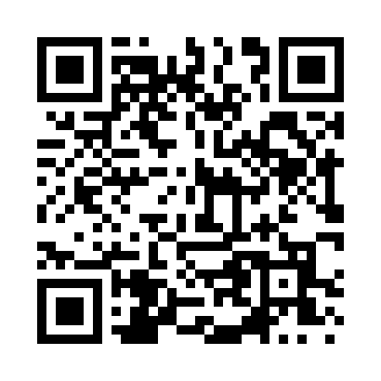
Prayer times for Brooks Grove, New York, USA
Mon 1 Jul 2024 - Wed 31 Jul 2024
High Latitude Method: Angle Based Rule
Prayer Calculation Method: Islamic Society of North America
Asar Calculation Method: Shafi

Date | Day | Fajr | Sunrise | Dhuhr | Asr | Maghrib | Isha
1 | Mon | 3:53 | 5:38 | 1:16 | 5:20 | 8:53 | 10:38
2 | Tue | 3:54 | 5:39 | 1:16 | 5:20 | 8:53 | 10:38
3 | Wed | 3:54 | 5:39 | 1:16 | 5:20 | 8:53 | 10:37
4 | Thu | 3:55 | 5:40 | 1:16 | 5:20 | 8:53 | 10:37
5 | Fri | 3:56 | 5:40 | 1:16 | 5:20 | 8:52 | 10:36
6 | Sat | 3:57 | 5:41 | 1:17 | 5:20 | 8:52 | 10:36
7 | Sun | 3:58 | 5:42 | 1:17 | 5:20 | 8:52 | 10:35
8 | Mon | 3:59 | 5:42 | 1:17 | 5:20 | 8:51 | 10:34
9 | Tue | 4:00 | 5:43 | 1:17 | 5:20 | 8:51 | 10:33
10 | Wed | 4:01 | 5:44 | 1:17 | 5:20 | 8:50 | 10:33
11 | Thu | 4:02 | 5:45 | 1:17 | 5:20 | 8:50 | 10:32
12 | Fri | 4:04 | 5:45 | 1:17 | 5:20 | 8:49 | 10:31
13 | Sat | 4:05 | 5:46 | 1:18 | 5:20 | 8:49 | 10:30
14 | Sun | 4:06 | 5:47 | 1:18 | 5:20 | 8:48 | 10:29
15 | Mon | 4:07 | 5:48 | 1:18 | 5:20 | 8:47 | 10:28
16 | Tue | 4:09 | 5:49 | 1:18 | 5:20 | 8:47 | 10:27
17 | Wed | 4:10 | 5:50 | 1:18 | 5:20 | 8:46 | 10:25
18 | Thu | 4:11 | 5:51 | 1:18 | 5:19 | 8:45 | 10:24
19 | Fri | 4:13 | 5:51 | 1:18 | 5:19 | 8:44 | 10:23
20 | Sat | 4:14 | 5:52 | 1:18 | 5:19 | 8:43 | 10:22
21 | Sun | 4:15 | 5:53 | 1:18 | 5:19 | 8:43 | 10:20
22 | Mon | 4:17 | 5:54 | 1:18 | 5:19 | 8:42 | 10:19
23 | Tue | 4:18 | 5:55 | 1:18 | 5:18 | 8:41 | 10:18
24 | Wed | 4:19 | 5:56 | 1:18 | 5:18 | 8:40 | 10:16
25 | Thu | 4:21 | 5:57 | 1:18 | 5:18 | 8:39 | 10:15
26 | Fri | 4:22 | 5:58 | 1:18 | 5:17 | 8:38 | 10:13
27 | Sat | 4:24 | 5:59 | 1:18 | 5:17 | 8:37 | 10:12
28 | Sun | 4:25 | 6:00 | 1:18 | 5:17 | 8:36 | 10:10
29 | Mon | 4:27 | 6:01 | 1:18 | 5:16 | 8:35 | 10:09
30 | Tue | 4:28 | 6:02 | 1:18 | 5:16 | 8:34 | 10:07
31 | Wed | 4:30 | 6:03 | 1:18 | 5:16 | 8:32 | 10:06
Prayer times provided by https://www.salahtimes.com

