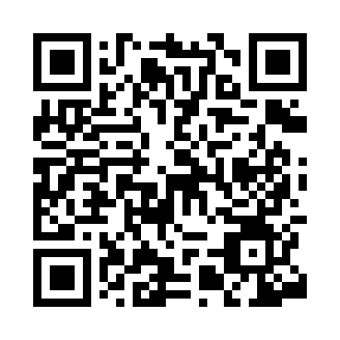

**Prayer times for Vicenza, Veneto, Italy**

**Fri 1 Nov 2024 - Sat 30 Nov 2024**

**High Latitude Method: Angle Based Rule**

**Prayer Calculation Method: Muslim World League**

**Asar Calculation Method: Hanafi**

|  |  |  |  |  |  |  |  |
| --- | --- | --- | --- | --- | --- | --- | --- |
| **Date** | **Day** | **Fajr** | **Sunrise** | **Dhuhr** | **Asr** | **Maghrib** | **Isha** |
| 1 | Fri | 5:13 | 6:54 | 11:57 | 3:16 | 5:00 | 6:35 |
| 2 | Sat | 5:15 | 6:55 | 11:57 | 3:15 | 4:59 | 6:34 |
| 3 | Sun | 5:16 | 6:57 | 11:57 | 3:13 | 4:57 | 6:33 |
| 4 | Mon | 5:17 | 6:58 | 11:57 | 3:12 | 4:56 | 6:31 |
| 5 | Tue | 5:18 | 6:59 | 11:57 | 3:11 | 4:55 | 6:30 |
| 6 | Wed | 5:19 | 7:01 | 11:57 | 3:09 | 4:53 | 6:29 |
| 7 | Thu | 5:21 | 7:02 | 11:58 | 3:08 | 4:52 | 6:28 |
| 8 | Fri | 5:22 | 7:04 | 11:58 | 3:07 | 4:51 | 6:27 |
| 9 | Sat | 5:23 | 7:05 | 11:58 | 3:06 | 4:50 | 6:26 |
| 10 | Sun | 5:24 | 7:06 | 11:58 | 3:05 | 4:48 | 6:25 |
| 11 | Mon | 5:26 | 7:08 | 11:58 | 3:04 | 4:47 | 6:24 |
| 12 | Tue | 5:27 | 7:09 | 11:58 | 3:02 | 4:46 | 6:23 |
| 13 | Wed | 5:28 | 7:11 | 11:58 | 3:01 | 4:45 | 6:22 |
| 14 | Thu | 5:29 | 7:12 | 11:58 | 3:00 | 4:44 | 6:21 |
| 15 | Fri | 5:30 | 7:13 | 11:58 | 2:59 | 4:43 | 6:20 |
| 16 | Sat | 5:31 | 7:15 | 11:59 | 2:58 | 4:42 | 6:20 |
| 17 | Sun | 5:33 | 7:16 | 11:59 | 2:58 | 4:41 | 6:19 |
| 18 | Mon | 5:34 | 7:17 | 11:59 | 2:57 | 4:40 | 6:18 |
| 19 | Tue | 5:35 | 7:19 | 11:59 | 2:56 | 4:39 | 6:17 |
| 20 | Wed | 5:36 | 7:20 | 12:00 | 2:55 | 4:38 | 6:17 |
| 21 | Thu | 5:37 | 7:21 | 12:00 | 2:54 | 4:38 | 6:16 |
| 22 | Fri | 5:38 | 7:23 | 12:00 | 2:53 | 4:37 | 6:16 |
| 23 | Sat | 5:39 | 7:24 | 12:00 | 2:53 | 4:36 | 6:15 |
| 24 | Sun | 5:40 | 7:25 | 12:01 | 2:52 | 4:35 | 6:15 |
| 25 | Mon | 5:41 | 7:27 | 12:01 | 2:51 | 4:35 | 6:14 |
| 26 | Tue | 5:43 | 7:28 | 12:01 | 2:51 | 4:34 | 6:14 |
| 27 | Wed | 5:44 | 7:29 | 12:02 | 2:50 | 4:34 | 6:13 |
| 28 | Thu | 5:45 | 7:30 | 12:02 | 2:50 | 4:33 | 6:13 |
| 29 | Fri | 5:46 | 7:32 | 12:02 | 2:49 | 4:33 | 6:13 |
| 30 | Sat | 5:47 | 7:33 | 12:03 | 2:49 | 4:32 | 6:12 |

**Prayer times provided by https://www.salahtimes.com**