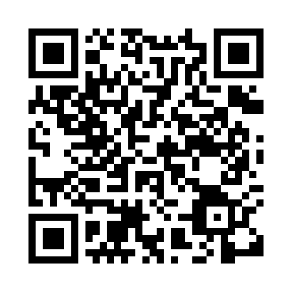
Prayer times for Ibri, Oman
Wed 1 May 2024 - Fri 31 May 2024
High Latitude Method: None
Prayer Calculation Method: Umm al-Qura, Makkah
Asar Calculation Method: Shafi

Date | Day | Fajr | Sunrise | Dhuhr | Asr | Maghrib | Isha
1 | Wed | 4:18 | 5:41 | 12:11 | 3:36 | 6:42 | 8:12
2 | Thu | 4:17 | 5:40 | 12:11 | 3:36 | 6:42 | 8:12
3 | Fri | 4:16 | 5:39 | 12:11 | 3:35 | 6:43 | 8:13
4 | Sat | 4:15 | 5:39 | 12:11 | 3:35 | 6:43 | 8:13
5 | Sun | 4:14 | 5:38 | 12:11 | 3:35 | 6:44 | 8:14
6 | Mon | 4:14 | 5:37 | 12:11 | 3:34 | 6:44 | 8:14
7 | Tue | 4:13 | 5:37 | 12:11 | 3:34 | 6:45 | 8:15
8 | Wed | 4:12 | 5:36 | 12:10 | 3:34 | 6:45 | 8:15
9 | Thu | 4:11 | 5:36 | 12:10 | 3:34 | 6:46 | 8:16
10 | Fri | 4:11 | 5:35 | 12:10 | 3:33 | 6:46 | 8:16
11 | Sat | 4:10 | 5:35 | 12:10 | 3:33 | 6:47 | 8:17
12 | Sun | 4:09 | 5:34 | 12:10 | 3:33 | 6:47 | 8:17
13 | Mon | 4:08 | 5:34 | 12:10 | 3:33 | 6:47 | 8:17
14 | Tue | 4:08 | 5:33 | 12:10 | 3:32 | 6:48 | 8:18
15 | Wed | 4:07 | 5:33 | 12:10 | 3:32 | 6:48 | 8:18
16 | Thu | 4:06 | 5:32 | 12:10 | 3:32 | 6:49 | 8:19
17 | Fri | 4:06 | 5:32 | 12:10 | 3:32 | 6:49 | 8:19
18 | Sat | 4:05 | 5:31 | 12:10 | 3:32 | 6:50 | 8:20
19 | Sun | 4:05 | 5:31 | 12:11 | 3:31 | 6:50 | 8:20
20 | Mon | 4:04 | 5:31 | 12:11 | 3:31 | 6:51 | 8:21
21 | Tue | 4:04 | 5:30 | 12:11 | 3:31 | 6:51 | 8:21
22 | Wed | 4:03 | 5:30 | 12:11 | 3:31 | 6:52 | 8:22
23 | Thu | 4:03 | 5:30 | 12:11 | 3:31 | 6:52 | 8:22
24 | Fri | 4:02 | 5:29 | 12:11 | 3:31 | 6:53 | 8:23
25 | Sat | 4:02 | 5:29 | 12:11 | 3:31 | 6:53 | 8:23
26 | Sun | 4:01 | 5:29 | 12:11 | 3:31 | 6:54 | 8:24
27 | Mon | 4:01 | 5:29 | 12:11 | 3:31 | 6:54 | 8:24
28 | Tue | 4:00 | 5:28 | 12:11 | 3:30 | 6:54 | 8:24
29 | Wed | 4:00 | 5:28 | 12:11 | 3:30 | 6:55 | 8:25
30 | Thu | 4:00 | 5:28 | 12:12 | 3:30 | 6:55 | 8:25
31 | Fri | 4:00 | 5:28 | 12:12 | 3:30 | 6:56 | 8:26
Prayer times provided by https://www.salahtimes.com

