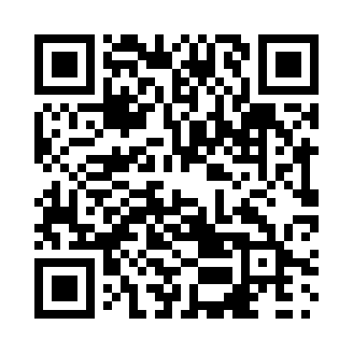
Prayer times for Bengough, Saskatchewan, Canada
Mon 1 Apr 2024 - Tue 30 Apr 2024
High Latitude Method: Angle Based Rule
Prayer Calculation Method: Islamic Society of North America
Asar Calculation Method: Hanafi

Date | Day | Fajr | Sunrise | Dhuhr | Asr | Maghrib | Isha
1 | Mon | 5:05 | 6:36 | 1:04 | 5:33 | 7:33 | 9:05
2 | Tue | 5:02 | 6:34 | 1:04 | 5:34 | 7:34 | 9:07
3 | Wed | 5:00 | 6:32 | 1:04 | 5:35 | 7:36 | 9:08
4 | Thu | 4:57 | 6:30 | 1:03 | 5:36 | 7:38 | 9:10
5 | Fri | 4:55 | 6:28 | 1:03 | 5:37 | 7:39 | 9:12
6 | Sat | 4:52 | 6:26 | 1:03 | 5:38 | 7:41 | 9:14
7 | Sun | 4:50 | 6:24 | 1:02 | 5:39 | 7:42 | 9:16
8 | Mon | 4:48 | 6:22 | 1:02 | 5:40 | 7:44 | 9:18
9 | Tue | 4:45 | 6:20 | 1:02 | 5:41 | 7:45 | 9:20
10 | Wed | 4:43 | 6:17 | 1:02 | 5:42 | 7:47 | 9:22
11 | Thu | 4:40 | 6:15 | 1:01 | 5:43 | 7:48 | 9:24
12 | Fri | 4:37 | 6:13 | 1:01 | 5:44 | 7:50 | 9:26
13 | Sat | 4:35 | 6:11 | 1:01 | 5:45 | 7:51 | 9:28
14 | Sun | 4:32 | 6:09 | 1:01 | 5:46 | 7:53 | 9:30
15 | Mon | 4:30 | 6:07 | 1:00 | 5:47 | 7:54 | 9:32
16 | Tue | 4:27 | 6:05 | 1:00 | 5:48 | 7:56 | 9:34
17 | Wed | 4:25 | 6:03 | 1:00 | 5:49 | 7:57 | 9:36
18 | Thu | 4:22 | 6:01 | 1:00 | 5:50 | 7:59 | 9:38
19 | Fri | 4:20 | 5:59 | 12:59 | 5:51 | 8:00 | 9:40
20 | Sat | 4:17 | 5:57 | 12:59 | 5:52 | 8:02 | 9:43
21 | Sun | 4:15 | 5:56 | 12:59 | 5:53 | 8:03 | 9:45
22 | Mon | 4:12 | 5:54 | 12:59 | 5:54 | 8:05 | 9:47
23 | Tue | 4:10 | 5:52 | 12:59 | 5:55 | 8:06 | 9:49
24 | Wed | 4:07 | 5:50 | 12:59 | 5:56 | 8:08 | 9:51
25 | Thu | 4:05 | 5:48 | 12:58 | 5:57 | 8:09 | 9:53
26 | Fri | 4:02 | 5:46 | 12:58 | 5:58 | 8:11 | 9:56
27 | Sat | 4:00 | 5:44 | 12:58 | 5:59 | 8:13 | 9:58
28 | Sun | 3:57 | 5:43 | 12:58 | 6:00 | 8:14 | 10:00
29 | Mon | 3:54 | 5:41 | 12:58 | 6:01 | 8:16 | 10:02
30 | Tue | 3:52 | 5:39 | 12:58 | 6:02 | 8:17 | 10:05
Prayer times provided by https://www.salahtimes.com

