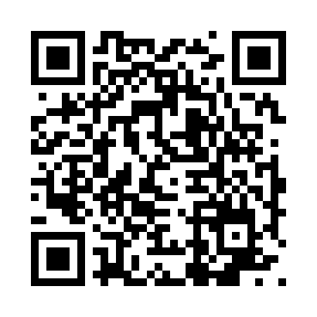

**Prayer times for Fortaleza, Brazil**

**Fri 1 Nov 2024 - Sat 30 Nov 2024**

**High Latitude Method: None**

**Prayer Calculation Method: Muslim World League**

**Asar Calculation Method: Shafi**

|  |  |  |  |  |  |  |  |
| --- | --- | --- | --- | --- | --- | --- | --- |
| **Date** | **Day** | **Fajr** | **Sunrise** | **Dhuhr** | **Asr** | **Maghrib** | **Isha** |
| 1 | Fri | 3:59 | 5:10 | 11:18 | 2:36 | 5:25 | 6:32 |
| 2 | Sat | 3:59 | 5:10 | 11:18 | 2:36 | 5:25 | 6:33 |
| 3 | Sun | 3:59 | 5:10 | 11:18 | 2:37 | 5:25 | 6:33 |
| 4 | Mon | 3:58 | 5:10 | 11:18 | 2:37 | 5:25 | 6:33 |
| 5 | Tue | 3:58 | 5:10 | 11:18 | 2:38 | 5:25 | 6:33 |
| 6 | Wed | 3:58 | 5:10 | 11:18 | 2:38 | 5:26 | 6:33 |
| 7 | Thu | 3:58 | 5:10 | 11:18 | 2:38 | 5:26 | 6:34 |
| 8 | Fri | 3:58 | 5:10 | 11:18 | 2:39 | 5:26 | 6:34 |
| 9 | Sat | 3:58 | 5:10 | 11:18 | 2:39 | 5:26 | 6:34 |
| 10 | Sun | 3:57 | 5:10 | 11:18 | 2:40 | 5:26 | 6:35 |
| 11 | Mon | 3:57 | 5:10 | 11:18 | 2:40 | 5:27 | 6:35 |
| 12 | Tue | 3:57 | 5:10 | 11:18 | 2:40 | 5:27 | 6:35 |
| 13 | Wed | 3:57 | 5:10 | 11:18 | 2:41 | 5:27 | 6:36 |
| 14 | Thu | 3:57 | 5:10 | 11:19 | 2:41 | 5:27 | 6:36 |
| 15 | Fri | 3:57 | 5:10 | 11:19 | 2:42 | 5:27 | 6:36 |
| 16 | Sat | 3:57 | 5:10 | 11:19 | 2:42 | 5:28 | 6:37 |
| 17 | Sun | 3:57 | 5:10 | 11:19 | 2:43 | 5:28 | 6:37 |
| 18 | Mon | 3:57 | 5:11 | 11:19 | 2:43 | 5:28 | 6:37 |
| 19 | Tue | 3:57 | 5:11 | 11:20 | 2:43 | 5:29 | 6:38 |
| 20 | Wed | 3:57 | 5:11 | 11:20 | 2:44 | 5:29 | 6:38 |
| 21 | Thu | 3:57 | 5:11 | 11:20 | 2:44 | 5:29 | 6:39 |
| 22 | Fri | 3:57 | 5:11 | 11:20 | 2:45 | 5:30 | 6:39 |
| 23 | Sat | 3:57 | 5:11 | 11:21 | 2:45 | 5:30 | 6:40 |
| 24 | Sun | 3:58 | 5:12 | 11:21 | 2:46 | 5:30 | 6:40 |
| 25 | Mon | 3:58 | 5:12 | 11:21 | 2:46 | 5:31 | 6:41 |
| 26 | Tue | 3:58 | 5:12 | 11:22 | 2:47 | 5:31 | 6:41 |
| 27 | Wed | 3:58 | 5:12 | 11:22 | 2:47 | 5:31 | 6:41 |
| 28 | Thu | 3:58 | 5:13 | 11:22 | 2:48 | 5:32 | 6:42 |
| 29 | Fri | 3:58 | 5:13 | 11:23 | 2:48 | 5:32 | 6:42 |
| 30 | Sat | 3:59 | 5:13 | 11:23 | 2:49 | 5:33 | 6:43 |

**Prayer times provided by https://www.salahtimes.com**