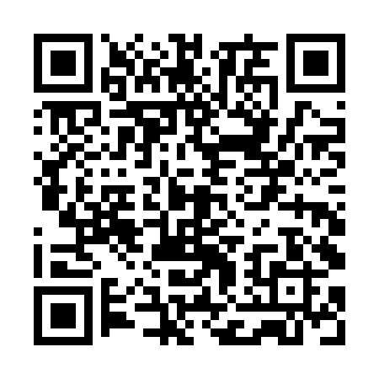
Prayer times for Baltrusiskiai, Lithuania
Wed 1 May 2024 - Fri 31 May 2024
High Latitude Method: Angle Based Rule
Prayer Calculation Method: Muslim World League
Asar Calculation Method: Hanafi

Date | Day | Fajr | Sunrise | Dhuhr | Asr | Maghrib | Isha
1 | Wed | 3:11 | 5:47 | 1:27 | 6:39 | 9:08 | 11:35
2 | Thu | 3:10 | 5:44 | 1:27 | 6:40 | 9:10 | 11:36
3 | Fri | 3:09 | 5:42 | 1:27 | 6:41 | 9:12 | 11:37
4 | Sat | 3:08 | 5:40 | 1:27 | 6:42 | 9:14 | 11:37
5 | Sun | 3:07 | 5:38 | 1:27 | 6:44 | 9:16 | 11:38
6 | Mon | 3:07 | 5:36 | 1:26 | 6:45 | 9:18 | 11:39
7 | Tue | 3:06 | 5:34 | 1:26 | 6:46 | 9:20 | 11:40
8 | Wed | 3:05 | 5:32 | 1:26 | 6:47 | 9:22 | 11:41
9 | Thu | 3:04 | 5:30 | 1:26 | 6:48 | 9:24 | 11:41
10 | Fri | 3:03 | 5:28 | 1:26 | 6:49 | 9:26 | 11:42
11 | Sat | 3:02 | 5:26 | 1:26 | 6:50 | 9:28 | 11:43
12 | Sun | 3:02 | 5:24 | 1:26 | 6:51 | 9:29 | 11:44
13 | Mon | 3:01 | 5:22 | 1:26 | 6:52 | 9:31 | 11:45
14 | Tue | 3:00 | 5:20 | 1:26 | 6:54 | 9:33 | 11:45
15 | Wed | 2:59 | 5:18 | 1:26 | 6:55 | 9:35 | 11:46
16 | Thu | 2:59 | 5:17 | 1:26 | 6:56 | 9:37 | 11:47
17 | Fri | 2:58 | 5:15 | 1:26 | 6:57 | 9:39 | 11:48
18 | Sat | 2:57 | 5:13 | 1:26 | 6:58 | 9:40 | 11:49
19 | Sun | 2:57 | 5:12 | 1:26 | 6:59 | 9:42 | 11:49
20 | Mon | 2:56 | 5:10 | 1:26 | 7:00 | 9:44 | 11:50
21 | Tue | 2:56 | 5:08 | 1:27 | 7:01 | 9:45 | 11:51
22 | Wed | 2:55 | 5:07 | 1:27 | 7:02 | 9:47 | 11:52
23 | Thu | 2:54 | 5:05 | 1:27 | 7:02 | 9:49 | 11:52
24 | Fri | 2:54 | 5:04 | 1:27 | 7:03 | 9:50 | 11:53
25 | Sat | 2:53 | 5:03 | 1:27 | 7:04 | 9:52 | 11:54
26 | Sun | 2:53 | 5:01 | 1:27 | 7:05 | 9:53 | 11:55
27 | Mon | 2:52 | 5:00 | 1:27 | 7:06 | 9:55 | 11:55
28 | Tue | 2:52 | 4:59 | 1:27 | 7:07 | 9:56 | 11:56
29 | Wed | 2:52 | 4:57 | 1:27 | 7:08 | 9:58 | 11:57
30 | Thu | 2:51 | 4:56 | 1:27 | 7:08 | 9:59 | 11:57
31 | Fri | 2:51 | 4:55 | 1:28 | 7:09 | 10:01 | 11:58
Prayer times provided by https://www.salahtimes.com

