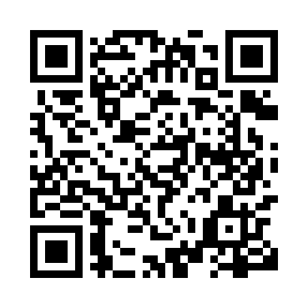
Prayer times for Grandmaison, New Brunswick, Canada
Wed 1 May 2024 - Fri 31 May 2024
High Latitude Method: Angle Based Rule
Prayer Calculation Method: Islamic Society of North America
Asar Calculation Method: Hanafi

Date | Day | Fajr | Sunrise | Dhuhr | Asr | Maghrib | Isha
1 | Wed | 4:34 | 6:16 | 1:31 | 6:34 | 8:46 | 10:28
2 | Thu | 4:32 | 6:14 | 1:30 | 6:34 | 8:48 | 10:30
3 | Fri | 4:30 | 6:13 | 1:30 | 6:35 | 8:49 | 10:32
4 | Sat | 4:28 | 6:11 | 1:30 | 6:36 | 8:50 | 10:34
5 | Sun | 4:25 | 6:09 | 1:30 | 6:37 | 8:52 | 10:36
6 | Mon | 4:23 | 6:08 | 1:30 | 6:38 | 8:53 | 10:38
7 | Tue | 4:21 | 6:07 | 1:30 | 6:39 | 8:54 | 10:40
8 | Wed | 4:19 | 6:05 | 1:30 | 6:39 | 8:56 | 10:42
9 | Thu | 4:17 | 6:04 | 1:30 | 6:40 | 8:57 | 10:44
10 | Fri | 4:15 | 6:02 | 1:30 | 6:41 | 8:58 | 10:46
11 | Sat | 4:12 | 6:01 | 1:30 | 6:42 | 9:00 | 10:49
12 | Sun | 4:10 | 6:00 | 1:30 | 6:43 | 9:01 | 10:51
13 | Mon | 4:08 | 5:58 | 1:30 | 6:43 | 9:02 | 10:53
14 | Tue | 4:06 | 5:57 | 1:30 | 6:44 | 9:03 | 10:55
15 | Wed | 4:04 | 5:56 | 1:30 | 6:45 | 9:05 | 10:57
16 | Thu | 4:02 | 5:55 | 1:30 | 6:46 | 9:06 | 10:59
17 | Fri | 4:00 | 5:53 | 1:30 | 6:46 | 9:07 | 11:01
18 | Sat | 3:58 | 5:52 | 1:30 | 6:47 | 9:08 | 11:03
19 | Sun | 3:56 | 5:51 | 1:30 | 6:48 | 9:10 | 11:05
20 | Mon | 3:54 | 5:50 | 1:30 | 6:48 | 9:11 | 11:07
21 | Tue | 3:53 | 5:49 | 1:30 | 6:49 | 9:12 | 11:09
22 | Wed | 3:51 | 5:48 | 1:30 | 6:50 | 9:13 | 11:11
23 | Thu | 3:49 | 5:47 | 1:30 | 6:50 | 9:14 | 11:13
24 | Fri | 3:47 | 5:46 | 1:30 | 6:51 | 9:15 | 11:15
25 | Sat | 3:46 | 5:45 | 1:31 | 6:52 | 9:16 | 11:16
26 | Sun | 3:44 | 5:44 | 1:31 | 6:52 | 9:18 | 11:18
27 | Mon | 3:42 | 5:43 | 1:31 | 6:53 | 9:19 | 11:20
28 | Tue | 3:41 | 5:43 | 1:31 | 6:54 | 9:20 | 11:22
29 | Wed | 3:39 | 5:42 | 1:31 | 6:54 | 9:21 | 11:24
30 | Thu | 3:38 | 5:41 | 1:31 | 6:55 | 9:22 | 11:25
31 | Fri | 3:36 | 5:41 | 1:31 | 6:55 | 9:23 | 11:27
Prayer times provided by https://www.salahtimes.com

