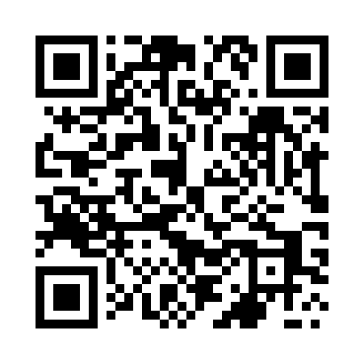

**Prayer times for Ublik, Poland**

**Sun 1 Sep 2024 - Mon 30 Sep 2024**

**High Latitude Method: Angle Based Rule**

**Prayer Calculation Method: Muslim World League**

**Asar Calculation Method: Hanafi**

|  |  |  |  |  |  |  |  |
| --- | --- | --- | --- | --- | --- | --- | --- |
| **Date** | **Day** | **Fajr** | **Sunrise** | **Dhuhr** | **Asr** | **Maghrib** | **Isha** |
| 1 | Sun | 3:26 | 5:42 | 12:32 | 5:12 | 7:22 | 9:27 |
| 2 | Mon | 3:29 | 5:43 | 12:32 | 5:10 | 7:20 | 9:24 |
| 3 | Tue | 3:32 | 5:45 | 12:32 | 5:08 | 7:17 | 9:21 |
| 4 | Wed | 3:35 | 5:47 | 12:31 | 5:06 | 7:15 | 9:17 |
| 5 | Thu | 3:37 | 5:49 | 12:31 | 5:04 | 7:12 | 9:14 |
| 6 | Fri | 3:40 | 5:50 | 12:31 | 5:02 | 7:10 | 9:11 |
| 7 | Sat | 3:42 | 5:52 | 12:30 | 5:00 | 7:07 | 9:08 |
| 8 | Sun | 3:45 | 5:54 | 12:30 | 4:58 | 7:05 | 9:05 |
| 9 | Mon | 3:48 | 5:56 | 12:30 | 4:56 | 7:02 | 9:02 |
| 10 | Tue | 3:50 | 5:57 | 12:29 | 4:54 | 7:00 | 8:59 |
| 11 | Wed | 3:52 | 5:59 | 12:29 | 4:52 | 6:58 | 8:56 |
| 12 | Thu | 3:55 | 6:01 | 12:29 | 4:50 | 6:55 | 8:53 |
| 13 | Fri | 3:57 | 6:03 | 12:28 | 4:48 | 6:53 | 8:50 |
| 14 | Sat | 4:00 | 6:04 | 12:28 | 4:46 | 6:50 | 8:47 |
| 15 | Sun | 4:02 | 6:06 | 12:27 | 4:44 | 6:48 | 8:44 |
| 16 | Mon | 4:04 | 6:08 | 12:27 | 4:42 | 6:45 | 8:41 |
| 17 | Tue | 4:07 | 6:10 | 12:27 | 4:40 | 6:43 | 8:38 |
| 18 | Wed | 4:09 | 6:12 | 12:26 | 4:38 | 6:40 | 8:35 |
| 19 | Thu | 4:11 | 6:13 | 12:26 | 4:36 | 6:38 | 8:32 |
| 20 | Fri | 4:13 | 6:15 | 12:26 | 4:34 | 6:35 | 8:29 |
| 21 | Sat | 4:15 | 6:17 | 12:25 | 4:32 | 6:33 | 8:26 |
| 22 | Sun | 4:18 | 6:19 | 12:25 | 4:30 | 6:30 | 8:23 |
| 23 | Mon | 4:20 | 6:20 | 12:25 | 4:28 | 6:28 | 8:21 |
| 24 | Tue | 4:22 | 6:22 | 12:24 | 4:25 | 6:25 | 8:18 |
| 25 | Wed | 4:24 | 6:24 | 12:24 | 4:23 | 6:23 | 8:15 |
| 26 | Thu | 4:26 | 6:26 | 12:24 | 4:21 | 6:20 | 8:12 |
| 27 | Fri | 4:28 | 6:28 | 12:23 | 4:19 | 6:18 | 8:10 |
| 28 | Sat | 4:30 | 6:29 | 12:23 | 4:17 | 6:15 | 8:07 |
| 29 | Sun | 4:32 | 6:31 | 12:23 | 4:15 | 6:13 | 8:04 |
| 30 | Mon | 4:34 | 6:33 | 12:22 | 4:13 | 6:10 | 8:02 |

**Prayer times provided by https://www.salahtimes.com**