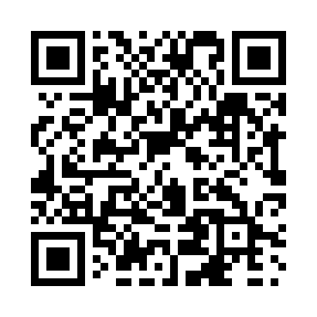
Prayer times for Bay Tree, Alberta, Canada
Wed 1 May 2024 - Fri 31 May 2024
High Latitude Method: Angle Based Rule
Prayer Calculation Method: Islamic Society of North America
Asar Calculation Method: Hanafi

Date | Day | Fajr | Sunrise | Dhuhr | Asr | Maghrib | Isha
1 | Wed | 4:06 | 6:15 | 1:57 | 7:09 | 9:40 | 11:48
2 | Thu | 4:05 | 6:12 | 1:57 | 7:11 | 9:42 | 11:49
3 | Fri | 4:04 | 6:10 | 1:56 | 7:12 | 9:44 | 11:50
4 | Sat | 4:02 | 6:08 | 1:56 | 7:13 | 9:46 | 11:51
5 | Sun | 4:01 | 6:06 | 1:56 | 7:14 | 9:48 | 11:52
6 | Mon | 4:00 | 6:04 | 1:56 | 7:15 | 9:50 | 11:53
7 | Tue | 3:59 | 6:02 | 1:56 | 7:16 | 9:52 | 11:54
8 | Wed | 3:58 | 6:00 | 1:56 | 7:18 | 9:53 | 11:55
9 | Thu | 3:57 | 5:58 | 1:56 | 7:19 | 9:55 | 11:56
10 | Fri | 3:56 | 5:56 | 1:56 | 7:20 | 9:57 | 11:57
11 | Sat | 3:55 | 5:54 | 1:56 | 7:21 | 9:59 | 11:58
12 | Sun | 3:54 | 5:52 | 1:56 | 7:22 | 10:01 | 11:59
13 | Mon | 3:53 | 5:50 | 1:56 | 7:23 | 10:03 | 12:00
14 | Tue | 3:52 | 5:48 | 1:56 | 7:24 | 10:05 | 12:01
15 | Wed | 3:51 | 5:46 | 1:56 | 7:25 | 10:07 | 12:02
16 | Thu | 3:50 | 5:44 | 1:56 | 7:26 | 10:09 | 12:02
17 | Fri | 3:50 | 5:43 | 1:56 | 7:27 | 10:10 | 12:03
18 | Sat | 3:49 | 5:41 | 1:56 | 7:28 | 10:12 | 12:04
19 | Sun | 3:48 | 5:39 | 1:56 | 7:29 | 10:14 | 12:05
20 | Mon | 3:47 | 5:38 | 1:56 | 7:30 | 10:16 | 12:06
21 | Tue | 3:46 | 5:36 | 1:56 | 7:31 | 10:17 | 12:07
22 | Wed | 3:46 | 5:35 | 1:56 | 7:32 | 10:19 | 12:08
23 | Thu | 3:45 | 5:33 | 1:56 | 7:33 | 10:21 | 12:09
24 | Fri | 3:44 | 5:32 | 1:57 | 7:34 | 10:22 | 12:10
25 | Sat | 3:44 | 5:30 | 1:57 | 7:35 | 10:24 | 12:10
26 | Sun | 3:43 | 5:29 | 1:57 | 7:36 | 10:25 | 12:11
27 | Mon | 3:42 | 5:28 | 1:57 | 7:37 | 10:27 | 12:12
28 | Tue | 3:42 | 5:26 | 1:57 | 7:37 | 10:28 | 12:13
29 | Wed | 3:41 | 5:25 | 1:57 | 7:38 | 10:30 | 12:14
30 | Thu | 3:41 | 5:24 | 1:57 | 7:39 | 10:31 | 12:14
31 | Fri | 3:40 | 5:23 | 1:57 | 7:40 | 10:33 | 12:15
Prayer times provided by https://www.salahtimes.com

