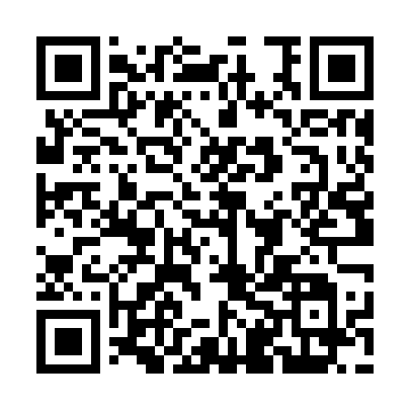
Prayer times for Selaschari, Bangladesh
Wed 1 May 2024 - Fri 31 May 2024
High Latitude Method: None
Prayer Calculation Method: University of Islamic Sciences
Asar Calculation Method: Shafi

Date | Day | Fajr | Sunrise | Dhuhr | Asr | Maghrib | Isha
1 | Wed | 3:59 | 5:19 | 11:49 | 3:13 | 6:19 | 7:39
2 | Thu | 3:58 | 5:18 | 11:48 | 3:12 | 6:19 | 7:39
3 | Fri | 3:57 | 5:17 | 11:48 | 3:12 | 6:20 | 7:40
4 | Sat | 3:56 | 5:17 | 11:48 | 3:12 | 6:20 | 7:41
5 | Sun | 3:55 | 5:16 | 11:48 | 3:11 | 6:21 | 7:41
6 | Mon | 3:55 | 5:15 | 11:48 | 3:11 | 6:21 | 7:42
7 | Tue | 3:54 | 5:15 | 11:48 | 3:11 | 6:21 | 7:43
8 | Wed | 3:53 | 5:14 | 11:48 | 3:10 | 6:22 | 7:43
9 | Thu | 3:52 | 5:14 | 11:48 | 3:10 | 6:22 | 7:44
10 | Fri | 3:52 | 5:13 | 11:48 | 3:10 | 6:23 | 7:45
11 | Sat | 3:51 | 5:13 | 11:48 | 3:10 | 6:23 | 7:45
12 | Sun | 3:50 | 5:12 | 11:48 | 3:09 | 6:24 | 7:46
13 | Mon | 3:49 | 5:12 | 11:48 | 3:09 | 6:24 | 7:47
14 | Tue | 3:49 | 5:11 | 11:48 | 3:09 | 6:25 | 7:47
15 | Wed | 3:48 | 5:11 | 11:48 | 3:09 | 6:25 | 7:48
16 | Thu | 3:48 | 5:10 | 11:48 | 3:09 | 6:26 | 7:48
17 | Fri | 3:47 | 5:10 | 11:48 | 3:08 | 6:26 | 7:49
18 | Sat | 3:46 | 5:09 | 11:48 | 3:08 | 6:27 | 7:50
19 | Sun | 3:46 | 5:09 | 11:48 | 3:08 | 6:27 | 7:50
20 | Mon | 3:45 | 5:09 | 11:48 | 3:08 | 6:27 | 7:51
21 | Tue | 3:45 | 5:08 | 11:48 | 3:08 | 6:28 | 7:52
22 | Wed | 3:44 | 5:08 | 11:48 | 3:07 | 6:28 | 7:52
23 | Thu | 3:44 | 5:08 | 11:48 | 3:07 | 6:29 | 7:53
24 | Fri | 3:43 | 5:08 | 11:48 | 3:07 | 6:29 | 7:54
25 | Sat | 3:43 | 5:07 | 11:48 | 3:07 | 6:30 | 7:54
26 | Sun | 3:42 | 5:07 | 11:49 | 3:07 | 6:30 | 7:55
27 | Mon | 3:42 | 5:07 | 11:49 | 3:07 | 6:31 | 7:55
28 | Tue | 3:42 | 5:07 | 11:49 | 3:07 | 6:31 | 7:56
29 | Wed | 3:41 | 5:06 | 11:49 | 3:07 | 6:32 | 7:57
30 | Thu | 3:41 | 5:06 | 11:49 | 3:07 | 6:32 | 7:57
31 | Fri | 3:41 | 5:06 | 11:49 | 3:07 | 6:32 | 7:58
Prayer times provided by https://www.salahtimes.com

