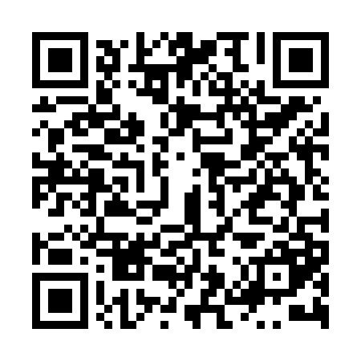

**Prayer times for Santa Cruz de Tenerife, Santa Cruz de Tenerife, Spain**

**Fri 1 Nov 2024 - Sat 30 Nov 2024**

**High Latitude Method: Angle Based Rule**

**Prayer Calculation Method: Muslim World League**

**Asar Calculation Method: Hanafi**

|  |  |  |  |  |  |  |  |
| --- | --- | --- | --- | --- | --- | --- | --- |
| **Date** | **Day** | **Fajr** | **Sunrise** | **Dhuhr** | **Asr** | **Maghrib** | **Isha** |
| 1 | Fri | 6:57 | 8:17 | 1:49 | 5:43 | 7:20 | 8:35 |
| 2 | Sat | 6:58 | 8:18 | 1:49 | 5:42 | 7:19 | 8:34 |
| 3 | Sun | 6:58 | 8:19 | 1:49 | 5:42 | 7:18 | 8:34 |
| 4 | Mon | 6:59 | 8:19 | 1:49 | 5:41 | 7:18 | 8:33 |
| 5 | Tue | 7:00 | 8:20 | 1:49 | 5:40 | 7:17 | 8:33 |
| 6 | Wed | 7:00 | 8:21 | 1:49 | 5:40 | 7:16 | 8:32 |
| 7 | Thu | 7:01 | 8:22 | 1:49 | 5:39 | 7:16 | 8:31 |
| 8 | Fri | 7:02 | 8:22 | 1:49 | 5:38 | 7:15 | 8:31 |
| 9 | Sat | 7:02 | 8:23 | 1:49 | 5:38 | 7:14 | 8:31 |
| 10 | Sun | 7:03 | 8:24 | 1:49 | 5:37 | 7:14 | 8:30 |
| 11 | Mon | 7:04 | 8:25 | 1:49 | 5:37 | 7:13 | 8:30 |
| 12 | Tue | 7:04 | 8:25 | 1:49 | 5:36 | 7:13 | 8:29 |
| 13 | Wed | 7:05 | 8:26 | 1:49 | 5:36 | 7:12 | 8:29 |
| 14 | Thu | 7:06 | 8:27 | 1:50 | 5:35 | 7:12 | 8:29 |
| 15 | Fri | 7:06 | 8:28 | 1:50 | 5:35 | 7:11 | 8:28 |
| 16 | Sat | 7:07 | 8:28 | 1:50 | 5:35 | 7:11 | 8:28 |
| 17 | Sun | 7:08 | 8:29 | 1:50 | 5:34 | 7:11 | 8:28 |
| 18 | Mon | 7:08 | 8:30 | 1:50 | 5:34 | 7:10 | 8:27 |
| 19 | Tue | 7:09 | 8:31 | 1:50 | 5:34 | 7:10 | 8:27 |
| 20 | Wed | 7:10 | 8:32 | 1:51 | 5:33 | 7:10 | 8:27 |
| 21 | Thu | 7:10 | 8:32 | 1:51 | 5:33 | 7:09 | 8:27 |
| 22 | Fri | 7:11 | 8:33 | 1:51 | 5:33 | 7:09 | 8:27 |
| 23 | Sat | 7:12 | 8:34 | 1:52 | 5:32 | 7:09 | 8:27 |
| 24 | Sun | 7:12 | 8:35 | 1:52 | 5:32 | 7:09 | 8:26 |
| 25 | Mon | 7:13 | 8:36 | 1:52 | 5:32 | 7:08 | 8:26 |
| 26 | Tue | 7:14 | 8:36 | 1:52 | 5:32 | 7:08 | 8:26 |
| 27 | Wed | 7:14 | 8:37 | 1:53 | 5:32 | 7:08 | 8:26 |
| 28 | Thu | 7:15 | 8:38 | 1:53 | 5:32 | 7:08 | 8:26 |
| 29 | Fri | 7:16 | 8:39 | 1:53 | 5:32 | 7:08 | 8:26 |
| 30 | Sat | 7:16 | 8:39 | 1:54 | 5:32 | 7:08 | 8:26 |

**Prayer times provided by https://www.salahtimes.com**