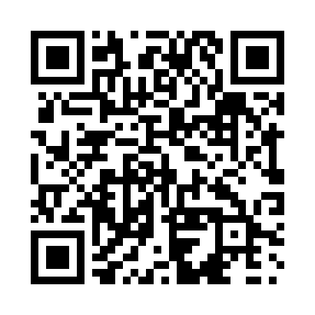
Prayer times for Beland, Quebec, Canada
Mon 1 Jul 2024 - Wed 31 Jul 2024
High Latitude Method: Angle Based Rule
Prayer Calculation Method: Islamic Society of North America
Asar Calculation Method: Hanafi

Date | Day | Fajr | Sunrise | Dhuhr | Asr | Maghrib | Isha
1 | Mon | 2:57 | 4:57 | 12:47 | 6:10 | 8:36 | 10:35
2 | Tue | 2:58 | 4:57 | 12:47 | 6:10 | 8:36 | 10:35
3 | Wed | 2:59 | 4:58 | 12:47 | 6:10 | 8:35 | 10:34
4 | Thu | 3:00 | 4:59 | 12:47 | 6:10 | 8:35 | 10:33
5 | Fri | 3:02 | 4:59 | 12:47 | 6:10 | 8:35 | 10:32
6 | Sat | 3:03 | 5:00 | 12:47 | 6:10 | 8:34 | 10:31
7 | Sun | 3:04 | 5:01 | 12:48 | 6:10 | 8:34 | 10:31
8 | Mon | 3:05 | 5:02 | 12:48 | 6:09 | 8:33 | 10:30
9 | Tue | 3:07 | 5:03 | 12:48 | 6:09 | 8:33 | 10:28
10 | Wed | 3:08 | 5:03 | 12:48 | 6:09 | 8:32 | 10:27
11 | Thu | 3:09 | 5:04 | 12:48 | 6:09 | 8:32 | 10:26
12 | Fri | 3:11 | 5:05 | 12:48 | 6:08 | 8:31 | 10:25
13 | Sat | 3:12 | 5:06 | 12:48 | 6:08 | 8:30 | 10:24
14 | Sun | 3:14 | 5:07 | 12:48 | 6:08 | 8:30 | 10:22
15 | Mon | 3:15 | 5:08 | 12:49 | 6:07 | 8:29 | 10:21
16 | Tue | 3:17 | 5:09 | 12:49 | 6:07 | 8:28 | 10:20
17 | Wed | 3:18 | 5:10 | 12:49 | 6:06 | 8:27 | 10:18
18 | Thu | 3:20 | 5:11 | 12:49 | 6:06 | 8:26 | 10:17
19 | Fri | 3:22 | 5:12 | 12:49 | 6:06 | 8:25 | 10:15
20 | Sat | 3:23 | 5:13 | 12:49 | 6:05 | 8:25 | 10:14
21 | Sun | 3:25 | 5:14 | 12:49 | 6:05 | 8:24 | 10:12
22 | Mon | 3:27 | 5:15 | 12:49 | 6:04 | 8:23 | 10:10
23 | Tue | 3:28 | 5:16 | 12:49 | 6:03 | 8:21 | 10:09
24 | Wed | 3:30 | 5:17 | 12:49 | 6:03 | 8:20 | 10:07
25 | Thu | 3:32 | 5:18 | 12:49 | 6:02 | 8:19 | 10:05
26 | Fri | 3:34 | 5:19 | 12:49 | 6:02 | 8:18 | 10:03
27 | Sat | 3:35 | 5:20 | 12:49 | 6:01 | 8:17 | 10:02
28 | Sun | 3:37 | 5:22 | 12:49 | 6:00 | 8:16 | 10:00
29 | Mon | 3:39 | 5:23 | 12:49 | 5:59 | 8:15 | 9:58
30 | Tue | 3:41 | 5:24 | 12:49 | 5:59 | 8:13 | 9:56
31 | Wed | 3:43 | 5:25 | 12:49 | 5:58 | 8:12 | 9:54
Prayer times provided by https://www.salahtimes.com

