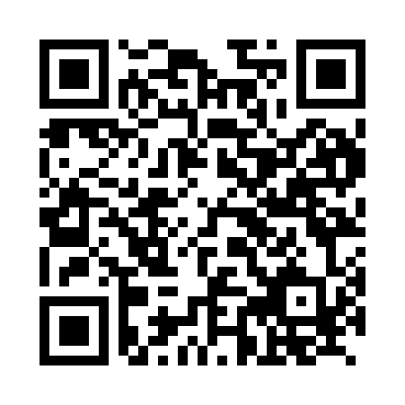

**Prayer times for Accumersiel, Germany**

**Sun 1 Sep 2024 - Mon 30 Sep 2024**

**High Latitude Method: Angle Based Rule**

**Prayer Calculation Method: Muslim World League**

**Asar Calculation Method: Shafi**

|  |  |  |  |  |  |  |  |
| --- | --- | --- | --- | --- | --- | --- | --- |
| **Date** | **Day** | **Fajr** | **Sunrise** | **Dhuhr** | **Asr** | **Maghrib** | **Isha** |
| 1 | Sun | 4:24 | 6:38 | 1:28 | 5:10 | 8:17 | 10:20 |
| 2 | Mon | 4:27 | 6:39 | 1:27 | 5:09 | 8:14 | 10:17 |
| 3 | Tue | 4:30 | 6:41 | 1:27 | 5:07 | 8:12 | 10:14 |
| 4 | Wed | 4:32 | 6:43 | 1:27 | 5:06 | 8:09 | 10:11 |
| 5 | Thu | 4:35 | 6:45 | 1:26 | 5:04 | 8:07 | 10:08 |
| 6 | Fri | 4:37 | 6:46 | 1:26 | 5:03 | 8:05 | 10:05 |
| 7 | Sat | 4:40 | 6:48 | 1:26 | 5:01 | 8:02 | 10:01 |
| 8 | Sun | 4:42 | 6:50 | 1:25 | 4:59 | 8:00 | 9:58 |
| 9 | Mon | 4:45 | 6:52 | 1:25 | 4:58 | 7:57 | 9:55 |
| 10 | Tue | 4:47 | 6:53 | 1:25 | 4:56 | 7:55 | 9:52 |
| 11 | Wed | 4:50 | 6:55 | 1:24 | 4:55 | 7:52 | 9:49 |
| 12 | Thu | 4:52 | 6:57 | 1:24 | 4:53 | 7:50 | 9:46 |
| 13 | Fri | 4:54 | 6:58 | 1:24 | 4:51 | 7:48 | 9:43 |
| 14 | Sat | 4:57 | 7:00 | 1:23 | 4:50 | 7:45 | 9:40 |
| 15 | Sun | 4:59 | 7:02 | 1:23 | 4:48 | 7:43 | 9:37 |
| 16 | Mon | 5:01 | 7:04 | 1:22 | 4:46 | 7:40 | 9:35 |
| 17 | Tue | 5:03 | 7:05 | 1:22 | 4:44 | 7:38 | 9:32 |
| 18 | Wed | 5:06 | 7:07 | 1:22 | 4:43 | 7:35 | 9:29 |
| 19 | Thu | 5:08 | 7:09 | 1:21 | 4:41 | 7:33 | 9:26 |
| 20 | Fri | 5:10 | 7:11 | 1:21 | 4:39 | 7:30 | 9:23 |
| 21 | Sat | 5:12 | 7:12 | 1:21 | 4:37 | 7:28 | 9:20 |
| 22 | Sun | 5:14 | 7:14 | 1:20 | 4:36 | 7:25 | 9:18 |
| 23 | Mon | 5:16 | 7:16 | 1:20 | 4:34 | 7:23 | 9:15 |
| 24 | Tue | 5:19 | 7:18 | 1:20 | 4:32 | 7:21 | 9:12 |
| 25 | Wed | 5:21 | 7:19 | 1:19 | 4:30 | 7:18 | 9:09 |
| 26 | Thu | 5:23 | 7:21 | 1:19 | 4:29 | 7:16 | 9:07 |
| 27 | Fri | 5:25 | 7:23 | 1:19 | 4:27 | 7:13 | 9:04 |
| 28 | Sat | 5:27 | 7:25 | 1:18 | 4:25 | 7:11 | 9:01 |
| 29 | Sun | 5:29 | 7:27 | 1:18 | 4:23 | 7:08 | 8:59 |
| 30 | Mon | 5:31 | 7:28 | 1:18 | 4:21 | 7:06 | 8:56 |

**Prayer times provided by https://www.salahtimes.com**