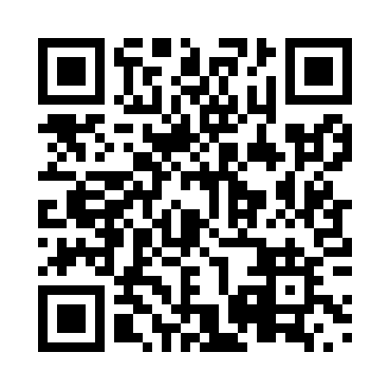
Prayer times for Desherbiers, New Brunswick, Canada
Mon 1 Apr 2024 - Tue 30 Apr 2024
High Latitude Method: Angle Based Rule
Prayer Calculation Method: Islamic Society of North America
Asar Calculation Method: Hanafi

Date | Day | Fajr | Sunrise | Dhuhr | Asr | Maghrib | Isha
1 | Mon | 5:33 | 6:59 | 1:25 | 5:54 | 7:51 | 9:17
2 | Tue | 5:31 | 6:57 | 1:24 | 5:55 | 7:52 | 9:19
3 | Wed | 5:29 | 6:55 | 1:24 | 5:56 | 7:53 | 9:20
4 | Thu | 5:27 | 6:53 | 1:24 | 5:56 | 7:55 | 9:22
5 | Fri | 5:24 | 6:52 | 1:23 | 5:57 | 7:56 | 9:24
6 | Sat | 5:22 | 6:50 | 1:23 | 5:58 | 7:57 | 9:25
7 | Sun | 5:20 | 6:48 | 1:23 | 5:59 | 7:59 | 9:27
8 | Mon | 5:18 | 6:46 | 1:23 | 6:00 | 8:00 | 9:29
9 | Tue | 5:15 | 6:44 | 1:22 | 6:01 | 8:02 | 9:30
10 | Wed | 5:13 | 6:42 | 1:22 | 6:02 | 8:03 | 9:32
11 | Thu | 5:11 | 6:40 | 1:22 | 6:03 | 8:04 | 9:34
12 | Fri | 5:09 | 6:38 | 1:22 | 6:04 | 8:06 | 9:35
13 | Sat | 5:06 | 6:36 | 1:21 | 6:05 | 8:07 | 9:37
14 | Sun | 5:04 | 6:35 | 1:21 | 6:06 | 8:08 | 9:39
15 | Mon | 5:02 | 6:33 | 1:21 | 6:07 | 8:10 | 9:41
16 | Tue | 5:00 | 6:31 | 1:21 | 6:07 | 8:11 | 9:43
17 | Wed | 4:57 | 6:29 | 1:20 | 6:08 | 8:12 | 9:44
18 | Thu | 4:55 | 6:27 | 1:20 | 6:09 | 8:14 | 9:46
19 | Fri | 4:53 | 6:25 | 1:20 | 6:10 | 8:15 | 9:48
20 | Sat | 4:51 | 6:24 | 1:20 | 6:11 | 8:16 | 9:50
21 | Sun | 4:48 | 6:22 | 1:19 | 6:12 | 8:18 | 9:52
22 | Mon | 4:46 | 6:20 | 1:19 | 6:13 | 8:19 | 9:53
23 | Tue | 4:44 | 6:18 | 1:19 | 6:14 | 8:21 | 9:55
24 | Wed | 4:42 | 6:17 | 1:19 | 6:14 | 8:22 | 9:57
25 | Thu | 4:40 | 6:15 | 1:19 | 6:15 | 8:23 | 9:59
26 | Fri | 4:37 | 6:13 | 1:19 | 6:16 | 8:25 | 10:01
27 | Sat | 4:35 | 6:12 | 1:18 | 6:17 | 8:26 | 10:03
28 | Sun | 4:33 | 6:10 | 1:18 | 6:18 | 8:27 | 10:05
29 | Mon | 4:31 | 6:09 | 1:18 | 6:18 | 8:29 | 10:07
30 | Tue | 4:29 | 6:07 | 1:18 | 6:19 | 8:30 | 10:09
Prayer times provided by https://www.salahtimes.com

