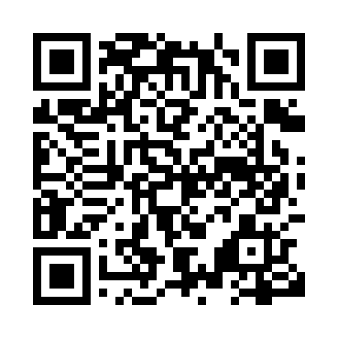
Prayer times for Camp Boggy, Newfoundland and Labrador, Canada
Mon 1 Apr 2024 - Tue 30 Apr 2024
High Latitude Method: Angle Based Rule
Prayer Calculation Method: Islamic Society of North America
Asar Calculation Method: Hanafi

Date | Day | Fajr | Sunrise | Dhuhr | Asr | Maghrib | Isha
1 | Mon | 5:22 | 6:51 | 1:17 | 5:46 | 7:44 | 9:13
2 | Tue | 5:20 | 6:48 | 1:17 | 5:47 | 7:46 | 9:15
3 | Wed | 5:17 | 6:46 | 1:16 | 5:48 | 7:47 | 9:16
4 | Thu | 5:15 | 6:44 | 1:16 | 5:49 | 7:48 | 9:18
5 | Fri | 5:13 | 6:42 | 1:16 | 5:50 | 7:50 | 9:20
6 | Sat | 5:10 | 6:40 | 1:15 | 5:51 | 7:51 | 9:22
7 | Sun | 5:08 | 6:38 | 1:15 | 5:52 | 7:53 | 9:23
8 | Mon | 5:06 | 6:36 | 1:15 | 5:53 | 7:54 | 9:25
9 | Tue | 5:03 | 6:34 | 1:15 | 5:54 | 7:56 | 9:27
10 | Wed | 5:01 | 6:32 | 1:14 | 5:55 | 7:57 | 9:29
11 | Thu | 4:59 | 6:31 | 1:14 | 5:56 | 7:58 | 9:31
12 | Fri | 4:56 | 6:29 | 1:14 | 5:57 | 8:00 | 9:33
13 | Sat | 4:54 | 6:27 | 1:14 | 5:57 | 8:01 | 9:35
14 | Sun | 4:51 | 6:25 | 1:13 | 5:58 | 8:03 | 9:36
15 | Mon | 4:49 | 6:23 | 1:13 | 5:59 | 8:04 | 9:38
16 | Tue | 4:47 | 6:21 | 1:13 | 6:00 | 8:06 | 9:40
17 | Wed | 4:44 | 6:19 | 1:13 | 6:01 | 8:07 | 9:42
18 | Thu | 4:42 | 6:17 | 1:12 | 6:02 | 8:09 | 9:44
19 | Fri | 4:40 | 6:15 | 1:12 | 6:03 | 8:10 | 9:46
20 | Sat | 4:37 | 6:13 | 1:12 | 6:04 | 8:11 | 9:48
21 | Sun | 4:35 | 6:12 | 1:12 | 6:05 | 8:13 | 9:50
22 | Mon | 4:32 | 6:10 | 1:12 | 6:06 | 8:14 | 9:52
23 | Tue | 4:30 | 6:08 | 1:11 | 6:07 | 8:16 | 9:54
24 | Wed | 4:28 | 6:06 | 1:11 | 6:08 | 8:17 | 9:56
25 | Thu | 4:25 | 6:04 | 1:11 | 6:09 | 8:19 | 9:58
26 | Fri | 4:23 | 6:03 | 1:11 | 6:09 | 8:20 | 10:00
27 | Sat | 4:21 | 6:01 | 1:11 | 6:10 | 8:21 | 10:02
28 | Sun | 4:18 | 5:59 | 1:11 | 6:11 | 8:23 | 10:04
29 | Mon | 4:16 | 5:58 | 1:10 | 6:12 | 8:24 | 10:06
30 | Tue | 4:14 | 5:56 | 1:10 | 6:13 | 8:26 | 10:08
Prayer times provided by https://www.salahtimes.com

